Clip it! Behavior Chart
Our classroom will use a clip chart to monitor behavior. A clip chart is a great tool that allows students to be rewarded for positive behavior, while discouraging negative behavior.
Each student has a clothes pin, or clip, with his or her number on it. Everyone will start on “Ready to Learn” at the beginning of each day, and clips can be moved up and down throughout the day based on behavior. Students will earn tickets to buy “special passes” every Friday!

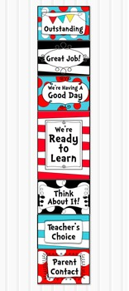
The “Outstanding” level is reserved for outstanding behavior. A student who reaches this level will receive 3 tickets for the day. Students should be ready to work, participating, on task, and focused.
Students can move to the “Great Job” level for continuing to display good behavior. A student who reaches this level will receive 2 tickets for the day. You should be very proud of your child for reaching this level!

Students will move to the “We’re Having A Good Day” level for showing that they are making the right behavior decisions! Students should have materials on their desk, pencil sharpened, homework out, basically ready to learn for the day. Ending the day on this level is great! Students who reach this level will receive 1 ticket at the end of the day.

Every student will start the day on the “Ready to Learn” level. As the day goes on, clips can be moved up and down, based on behavior. This level is a good one to be on!

A student will be moved to the “Think About It” level as a warning about his/her behavior, and a reminder to follow the rules.

Students who continue to display poor behavior can move down to the “Teacher’s Choice” level. Here the student will lose classroom “free time” minutes.

When a student moves to the “Parent Contact” level, the teacher will notify parents via note or phone call. A visit to the Principal’s office might also be in order, if necessary.

