Name ________________________________________ Period _________

Problem of the Week
April 23-27

Directions: Complete the following word problem by showing ALL your work and answering in a complete sentence. Remember the non-negotiables when answering.
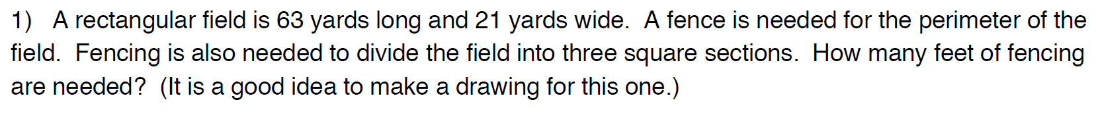

Sentence:
___________________________________________________________
___________________________________________________________

