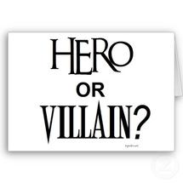

Julius caesar’s obituary
Obituary: a written notice of the death of a person, often with a biographical sketch in a newspaper
DIRECTIONS: Write an obituary for Julius Caesar from the viewpoint of how either antony or brutus might have written it.
Write in complete sentences and in paragraph form. Remember to write with word choice that shows how Antony or brutus felt about Caesar. Include:
- Date of caesar’s death
- One 6-10 word sentence that describes Caesar’s life In general
- Biographical information—who was Julius Caesar?
  - What was his title when he died?
  - What was he known for?
  - What area did he control?
- What are some of the reforms he made?
- What are some of his accomplishments?
- How did Caesar die? Why?
- What was the effect of caesar’s death on society?
- Day, time, and location of Caesar’s funeral
- End with a famous quote of caesar’s.
Include a sketch of Caesar. This can be hand-drawn or an online image.
*Use a tablet to research any of the information you do not have.
https://www.ducksters.com/history/ancient_rome/julius_caesar.php
https://www.brainyquote.com/authors/julius_caesar
https://www.biography.com/people/julius-caesar-9192504

