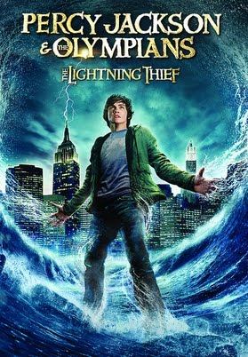
Dear Parents,
To conclude our novel, we will be watching the movie Lightening Thief (Rated PG). As a class, we will be comparing and contrasting the differences between the film and the novel (CCSS RL 6.7).
Please complete the form below either authorizing or exempting your child from viewing the film by Friday, February 2, 2018. Students who do not view this film will be given a relevant and appropriate alternative assignment.
Feel free to phone or email if you have questions.
Mrs. Becker & Ms. Hourihan

Student Name _____________________ Period __________
____ Yes, I give my son/daughter permission to view curriculum and school appropriate film/videos related to classroom content and subjects (Lightening Thief)
____ No, I do not give my son/daughter permission to view curriculum and school appropriate film/videos mentioned in this letter. I understand alternate learning experiences will be provided for my child while the movie is being watched.

Parent Signature __________________________________ Date ________

