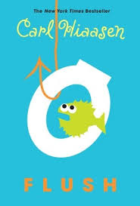
Dear Parents,
First quarter, students will be reading our first novel of the school year. As a Language Arts department, we have decided to read the novel, Flush by Carl Hiaasen.
We are asking that each student has his/her own copy of the book. We will work on book noting techniques, reading both at home and at school, along with other skills that will require students to have their own copy. The book is available for purchase through Barnes and Noble, or on Amazon.com.
Students will need a copy of the book by September 5th. Thank you very much for your support!
Hilda Walker 6th grade Language Arts Department
Mrs. Becker
Mrs. Hourihan

