Reading Project

Title/Author/Illustration/Genre - The title, author, and a specific genre (mystery, realistic fiction, adventure, etc.) must be displayed on your poster. You must also include an illustration to represent your novel. It needs to be colored and hand-drawn. Do not copy the picture from the front of your book.

Summary - On your poster, write a summary of your book. It must be at least ten sentences long, and it needs to be in your own words. Do not copy the summary from a website or the back of the book. REMEMBER: a summary includes only the important elements of a story, not every detail.

Rating - Give your book a rating. Five stars means you loved it! One star means you didn’t enjoy it. Explain in three sentences why you did or did not like your book. Tell readers why you would or would not recommend it.

Quotes - Choose two quotes from your novel to include on your poster. The quotes should be significant to the meaning of the novel. Underneath each quote, write two sentences explaining why you think it is important. You will use these quotes in your oral presentation when you give your book talk.

Other - You have a choice for the last item on your poster. Choose TWO of the following: Character Analysis, Setting, Theme, or Figurative Language.

Character Analysis – Choose a character to analyze. Describe the character. Why is this character significant to the novel? Length – 5 sentences
Setting – Describe the setting (where and when does the story take place? Is the setting crucial to the story? Explain. Length – Four sentences.
Theme – What was the overall theme or theme topic of the novel? What message does the reader learn at the end? Do the characters understand the theme at the end of the novel? Length – Five sentences.
Figurative Language – Locate one example of figurative language in the novel. (Simile, Metaphor, Personification, Idiom, Symbolism) What was significant about this example? Quote the example from the text and then explain it. Length – Quote + 3 sentences

Information may be typed or handwritten and should be neatly attached to your poster.

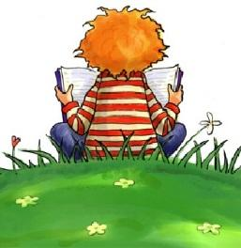

Reading Project Rubric

Creativity 0 1 2 3
Neatness 0 1 2 3
Title/Author/Genre 0 1 2 3
Illustration 0 1 2 3
Summary 0 1 2 3 4
Rating 0 1 2 3 4
Quote #1 0 1 2 3 4
Quote #2 0 1 2 3 4
Other 0 1 2 3 4
Other 0 1 2 3 4

Total: 36 Points Received: ________

