Title: Give the title for your lab or experiment

Example: Gum and testing

Problem/Questions: What are you trying to solve by doing this lab/experiment. This must be worded in the form of a questions. It is NOT what is wrong with your lab/experiment. *Be specific*

Example: Will chewing gum during a test raise the overall score on the test?

Purpose: What are you trying to find out by doing the lab/experiment? Give a personal connection as well. The purpose is worded “to determine”

Example: The purpose of this experiment is to determine if chewing gum during a test will raise the overall scores. I am testing this because we take many tests and I want to know if this helps.

Hypothesis: An educated guess as to what you think will during the experiment/lab. This is worded as an “if, then” statement. Be specific.

Example: If I give 10 students in my class a math test without chewing gum and I give those same students a similar but different test and allow them to chew one piece of peppermint gum then, the students’ scores while chewing gum will be higher.

Independent variable: What is being tested or changed (x axis)
Dependent variable: What is being measured (y axis)
Control: The unchanged group (normal way). Some experiments will not have a control.
Constants: All of the things that you will keep the same.

Example:
Independent variable: Gum chewing
Dependent variable: Test scores
Control: Not chewing gum
Constants: Students math ability, size and mount of gum, and testing environment

Materials: A detailed list of what you need to complete the lab/experiment

Example:
10 students with similar math ability
10 pieces of Extra peppermint gum
10 copies of test A
10 copies of test B
10 pencils
1 testing spot

Procedure: Detailed steps on how to complete the lab/experminet

Example:
- Gather test subjects
- Give the students test A
- Collect test when they are finished
- Give students one piece of Extra peppermint gum
- Give students test B
- Collect tests when finished
- Grade tests
- Record and analyze the data

Written Results: In paragraph form write out what happened in the lab/experiment.

Example:
Three students scored less than a 50% on test A. Two student’s scored a 78% on test A. One student scored a 65% on test A. Three students 85% on test A. The final student scored a 90% on test A. Nine out of the ten students increased their score on test B. One student scored the same on test B. Zero students scored worse on test B while chewing gum.

Data tables and graphs: This is a visual representation of the data collected. When creating data tables and graphs you must:
Use graph paper if you are making it by hand.
Use a ruler on all aspects
Label the x and y axis
Put labels on your x and y axis
Write a specific title
Use appropriate increments on the graph

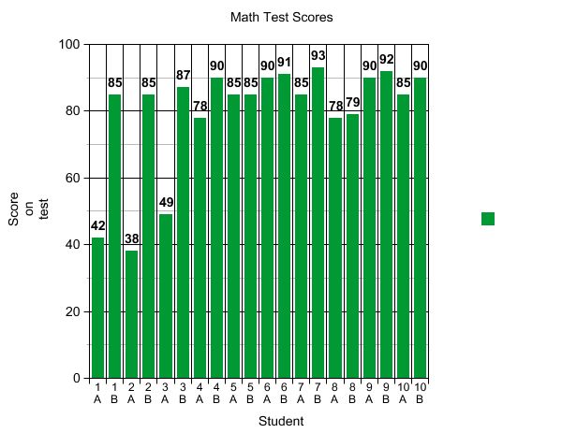
Conclusion: Include the following to close up your lab/experiment.
- Did you prove or disprove your hypothesis? It is okay if you disproved it.
- Explain why it happened.
- Give future plans about this lab/experiment

Example: I mostly proved my hypothesis correct because nine out the ten students improved their test score while one student kept the same score. I think this happened because the peppermint made the students become more focused on the questions. In the future I would test the students with chewing gum and with a paper/pencil test verses an online test like NWEA.

