Name: ______________________________________ Date: ________________________

Student Exploration: Half-life

Vocabulary: daughter atom, decay, Geiger counter, half-life, isotope, neutron, radiation, radioactive, radiometric dating

Prior Knowledge Questions (Do these BEFORE using the Gizmo.)

- Have you ever made microwave popcorn? If so, what do you hear while the popcorn is in the microwave? ____________________________________________________________
_________________________________________________________________________

- If you turn the microwave on for two minutes, is the rate of popping always the same, or does it change? Explain. _____________________________________________________
_________________________________________________________________________

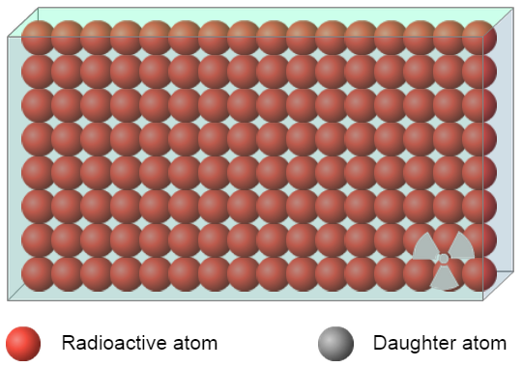
Gizmo Warm-up
Like an unpopped kernel in the microwave, a radioactive atom can change at any time. Radioactive atoms change by emitting radiation in the form of tiny particles and/or energy. This process, called decay, causes the radioactive atom to change into a stable daughter atom.

The Half-life Gizmo™ allows you to observe and measure the decay of a radioactive substance. Be sure the sound is turned on and click Play ( ).

- What do you see and hear? __________________________________________________

_________________________________________________________________________

Note: The clicking sound you hear comes from a Geiger counter, an instrument that detects the particles and energy emitted by decaying radioactive atoms.

- What remains at the end of the decay process? ___________________________________

- Is the rate of decay fastest at the beginning, middle, or end of the process? _____________

Activity A:  Decay curves | Get the Gizmo ready:  - Click Reset (). Be sure that User chooses half-life and Random decay are selected.  - Check that the Half-life is 20 seconds and the Number of atoms is 128. | 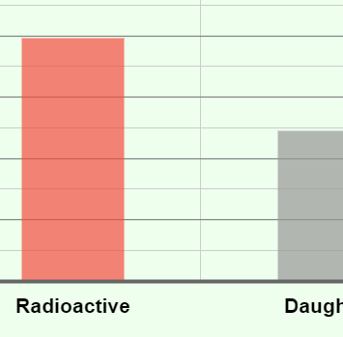

Question: How do we measure the rate of radioactive decay?

- Observe: Select the BAR CHART on the right side of the Gizmo and click Play.

    - What happens to the numbers of radioactive and daughter atoms as the simulation proceeds? __________________________________________________________
___________________________________________________________________

    - Do the numbers of radioactive and daughter atoms change at the same rate throughout the simulation? Explain. _______________________________________
___________________________________________________________________

- Experiment: Click Reset, and select the GRAPH tab. Run a simulation with the Half-life set to 5 seconds and another simulation with the Half-life set to 35 seconds. Sketch each resulting decay curve graph in the spaces below.

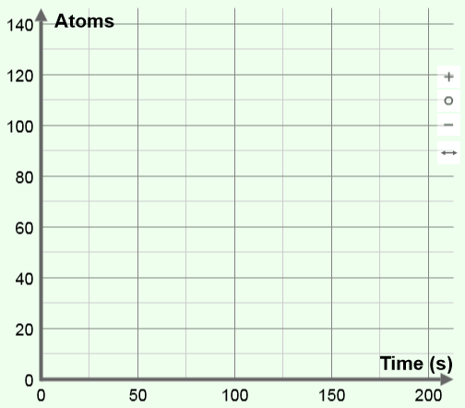

Half-life = 5 seconds Half-life = 35 seconds

- Interpret: How does the Half-life setting affect how quickly the simulated substance decays?

_________________________________________________________________________

_________________________________________________________________________

(Activity A continued on next page)
Activity A (continued from previous page)

- Collect data: Click Reset. Change the Half-life to 10 seconds and click Play. Select the TABLE tab and record the number of radioactive atoms at each given time below.

0 s: _____ 10 s: _____ 20 s: _____ 30 s: _____ 40 s: _____ 50 s: _____

- Analyze: What pattern, if any, do you see in your data? _____________________________

_________________________________________________________________________

- Revise and repeat: Use your data from #4 above to fill in the first line of the data table below. Then repeat the experiment four more times. Calculate the average number of radioactive atoms for each time.

Trial | 0 s | 10 s | 20 s | 30 s | 40 s | 50 s
1
2
3
4
5

Averages:

- Analyze: A half-life is defined as the amount of time it takes for half of the radioactive particles to decay. For the simulated substance, every 10 seconds represents one half-life.

How does your data demonstrate the definition of a half-life? _________________________

_________________________________________________________________________

_________________________________________________________________________

- Revise and repeat: Click Reset. Real radioactive samples will contain billions of radioactive atoms. To model the decay of a large sample, change from Random decay to Theoretical decay on the SIMULATION pane. Click Play and record the numbers of radioactive atoms:

0 s: _____ 10 s: _____ 20 s: _____ 30 s: _____ 40 s: _____ 50 s: _____

How does this data demonstrate the meaning of half-life? ___________________________

_________________________________________________________________________

_________________________________________________________________________

Activity B:  Measuring half-life | Get the Gizmo ready:  - Click Reset.  - Select Isotope A from the left drop-down menu.  - Check that Theoretical decay is selected. | 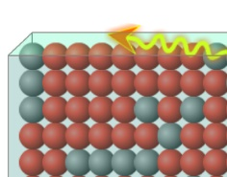

Introduction: Different isotopes of the same element have the same number of protons but different numbers of neutrons in the nucleus. Some isotopes are radioactive.

Question: How do we find the half-life of a radioactive isotope?

- Observe: Select the GRAPH tab, and click Play. Based on the graph, what is your estimate of the half-life of isotope A? ________________________

- Measure: Turn on the Half-life probe. Use the probe to measure how long it takes for exactly one-half of the original radioactive atoms to decay.

What is the exact half-life of isotope A? ________________________

- Collect data: In the first row of the table below, write how many seconds represent one half-life, two half-lives, and so forth. On the next row, predict the number of radioactive atoms that will be present at each time. Then use the probe to find the actual values.

Half-life | 0 | 1 | 2 | 3 | 4 | 5
Time (seconds)
Predicted # radioactive atoms
Actual # radioactive atoms

- Calculate: Calculate the percentage of radioactive atoms that are left after each half-life.

Half-life | 0 | 1 | 2 | 3 | 4 | 5
Percentage radioactive atoms

- Apply: Suppose you found a material in which 12.5% of the original radioactive atoms were present. If the half-life is 47 years, how old is the material? __________________________
(Activity B continued on next page)
Activity B (continued from previous page)

- Apply: Use the Gizmo to find the half-life of Isotope B. What is it? ____________________

- Practice: Click Reset. Select the Mystery half-life from the left menu. In this setting, the half-life will be different each time you run the simulation. Run at least three trials. In each trial, measure the half-life using the Half-life probe on the graph.

When you have found the half-life, click the camera () icon. Right-click the image, and click Copy. Then paste the image into a blank document, and label each image with the half-life. Print out this document and turn it in with this sheet.

- Explore: Use the Gizmo to explore whether the number of atoms present affects the half-life that you measure. Describe your findings below:

_________________________________________________________________________

_________________________________________________________________________

_________________________________________________________________________

_________________________________________________________________________

- Extend your thinking: The slow decay of radioactive materials can be used to find the age of rocks, fossils, and archaeological artifacts. In a process called radiometric dating, scientists measure the proportions of radioactive atoms and daughter atoms in an object to determine its age. Carbon-14 is a useful isotope because it is found in wood, ash, bone, and any other organic materials.

You can use the Half-life Gizmo to model the decay of Carbon-14, which has a half-life of approximately 6,000 years (actual value is 5,730 years). In the Gizmo, select User chooses half-life and Theoretical decay. Set the Half-life to 6 seconds (to represent 6,000 years) and the Number of atoms to 100.

Use the Gizmo to estimate the age of each of the objects below. For these questions, each second in the Gizmo represents 1,000 years.

Description | Age (years)
Egyptian papyrus with 63% of its original carbon-14 atoms
Aboriginal charcoal with 22% of its original carbon-14 atoms.
Mayan headdress with 79% of its original carbon-14 atoms
Neanderthal skull with 3% of its original carbon-14 atoms

