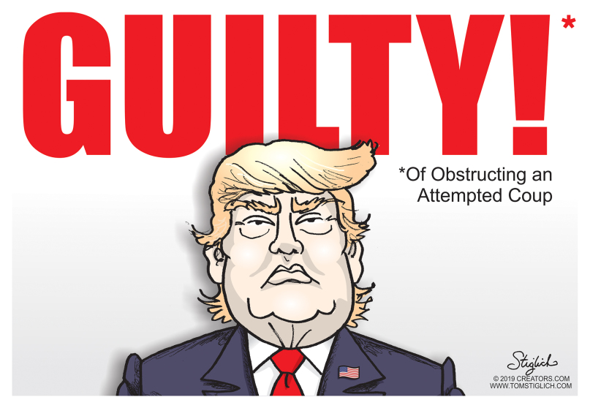
- Who is pictured?
- What is he guilty of?
- What is a coup?
- Why is it funny?

