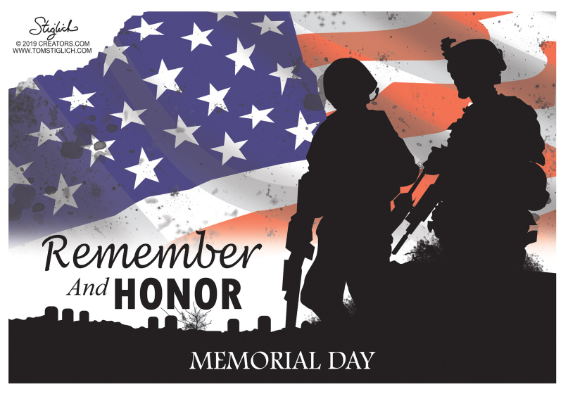
- What holiday was yesterday?
- Who do we remember & honor?
- Where is the U.S.A.’s military stationed?
- Why is it important?

