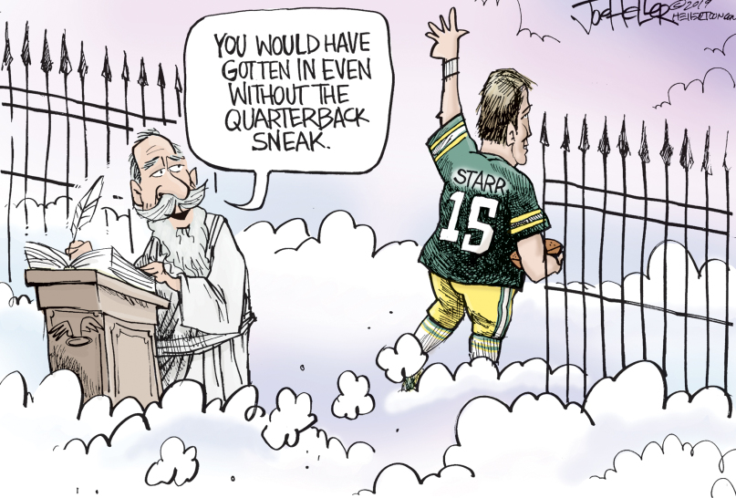
- Who passed away?
- What team did he play for?
- Who is the saint at the gate?
- Why is it sad?

