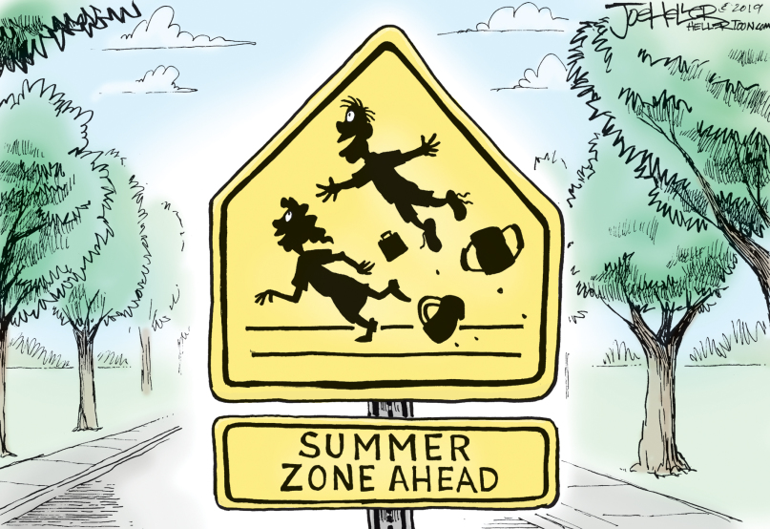
- What lies ahead?
- Who is on the sign?
- What are you doing this summer?
- Why is it fantastic?

