QUESTIONS:
- An organ consists of _________________________________________________________.
- An organ system consists of ___________________________________________________.
- The highest level of organization is the ____________________________.
- What are the 3 parts of the Cell Theory:

- What part of the cell forms a barrier between the cell and its environment?_______________________________________________________________.
- What part of the cell keeps the cell membrane from collapsing?_______________________.
- Where are ribosomes found – what organelle?_____________________________________.
- What part of the cell acts as the cell’s delivery system?______________________________.
- Energy released by a cell’s mitochondrion is stored in the _______________.
- What cell parts carry materials between organelles, such as ER and the Golgi complex?
_____________________________________
- What is the large vesicle that aids in digestion within plant cells called?____________________.
- What are organisms made of?___________________________________________________.
- What protects the inside of a cell from the outside world?____________________________.
- Why did Robert Hooke NOT think that animals had cells?________________________________________________________________________________________________________________________________________________________.
- What year was The Cell Theory developed in?____________________________
- The complex sugar cellulose is found in the cell walls of _______________________________.
- What is cytoplasm?_____________________________________________________________.
- What is the job of the lysosomes?__________________________________________________.
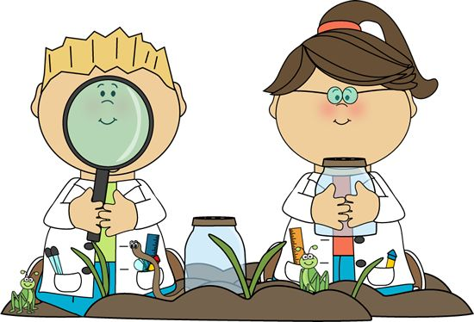
CELL PARTS AND FUNCTIONS:
Cell membrane__________________________________________________________________
Cell wall________________________________________________________________________
Chloroplast_____________________________________________________________________
Cytoskeleton____________________________________________________________________
Endoplasmic reticulum____________________________________________________________
Golgi complex___________________________________________________________________
Lysosomes______________________________________________________________________
Mitochondrion___________________________________________________________________
Nucleus_________________________________________________________________________
Ribosomes_______________________________________________________________________
