CHAPTER 3 HERDITY STUDY GUIDE
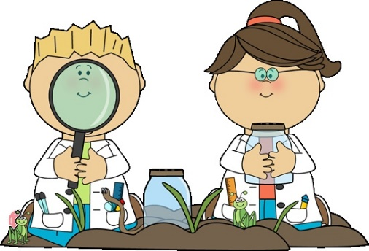
- What step did Mendel take to make sure his pea plants cross-pollinated?
- What happens when a true-breeding plant cross-pollinates?
- Each parent gives one set of what to their offspring?
- A plant with two dominant OR two recessive alleles is said to be __________________.
- How are sex cells different from other human cells?
- What are homologous chromosomes?

- Why do sex-linked disorders occur more often in males?

- What carries the genes that determine sex?
- What are the instructions for an inherited trait called?
- What are the different forms of a gene?
- What did Mendel discover about recessive traits?

- What is the diagram used to trace a trait called?

- What are chromosomes called that carry the same set of genes?

- What is a feature that has different forms in a population?

- What is a trait?

- When a plant fertilizes itself, it is called?

- What is incomplete dominance?

- What kind of plant produces offspring with the same traits as the parent?

- What do you call one set of instructions for an inherited trait?

- Two forms of a gene, one from each parent, are called?

- Offspring that are different from both parents are produced by?

- What are chromosomes called that carry the same set of genes?

- What is heredity?

- What is a plant that has two dominant genes or two recessive genes called?

- What is Mendel’s ratio for dominant to recessive traits?

- What is a phenotype?

- What is it called when cells are copied with half the number of chromosomes?

DEFINITIONS:
PHENOTYPE:

PUNNETT SQUARE:

HOMOZYGOUS:

HETEROZYGOUS:

CROSS-POLLINATION:

PROBABILITY:

GENOTYPE:

SELF-POLLINATING:

INCOMPLETE DOMINANCE:

SEX CELLS:

TRUE-BREEDING PLANTS:

