STRAWBERRY DNA LAB
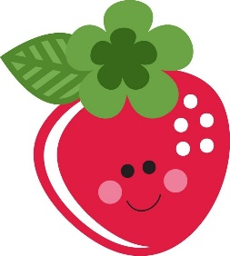
PURPOSE: To extract DNA from a strawberry.
HYPOTHESIS: If I use an extraction buffer solution, made of water, soap, and salt, then I can extract DNA from a strawberry.
MATERIALS:
- Strawberry
- Beaker
- Coffee Filter
- Ziploc Bag
- Rubbing Alcohol
- Glass Stirring Rod

PROCEDURE:
- Place one strawberry in a Ziploc bag.

DATA:
After Adding Rubbing Alcohol -  What did I see? | After dipping in the glass stirring into strawberry solution –  What did I see?
RESULTS: (Answer the following questions for this lab INSTEAD of 3 I Learned Statements)
- What did the DNA look like? Relate what you know about the chemical structure of DNA to what you observed today.

- Explain what happened in the final step when you added rubbing alcohol to your strawberry extract. (Hint: DNA is soluble (able to dissolve) in water, but not in rubbing alcohol.)

- A person can see a single cotton thread 100 feet away, but if you wound thousands of threads together into a rope, it would be visible much farther away. Is this statement true for our DNA extraction? Explain.

- Why is it important for scientists to be able to remove DNA from an organism? List two reasons.

CONCLUSIONS: (Restate your hypothesis, sum up data, and future plans)
____________________________________________________________________________________________________________________________________________________________________________________________________________________________________________________________________________________________________________________________________________________________________________________________________________________________________________________________________________________

