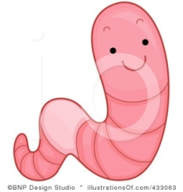
Junior Biologist:_________________________ Period:____________________

EARTHWORM LAB
Purpose: To determine if earthworms prefer dry or moist environments? To determine which surface an earthworm would travel the fastest on – construction paper, tin foil, or saran wrap.

Hypothesis: If_____________________________________________________________________________________________________________________________________________
Then__________________________________________________________________________________________________________________________________________________________________________________________________________________.

Materials:
For Dry/ Wet Experiment:
- Live earthworm
- Water
- Tray
- Eye dropper – to keep earthworm moist
- Paper towels
- Timer
- Construction paper, tin foil, saran wrap
- Flashlight (share please)
- Magnifying lens

Procedure:
- Gather materials.
- Set up your dry/wet environment
- Place earthworm in its environment
- Count the segments using the magnifying lens
- Record your observations in your data table.
- Place earthworm on tin foil, construction paper, and saran wrap.
- Place the earthworm on each of the above surfaces.
- Time how long the earthworm moves on each surface – 10 cm.
- Record your data.

Draw a picture of the set up:

DATA:
Surface: | Observation:
Tin Foil | _______ Seconds | ____10_____ cm
Construction Paper | _______ Seconds | _____10____ cm
Saran Wrap | _______ Seconds | _____10____ cm
Number of Segments | ____________ Segments

CLEAN UP (wash all equipment and hands)
MAKE SURE TO PLACE YOUR WORM IN THE DESIGNATED AREA.
Results: (2-3 Sentences about what you learned)

Conclusion: (Was Hypothesis Correct? Evidence Statement – rewrite data in sentence format. Future Plans) - ALL 3 PARTS MUST BE INCLUDED!

