7th Grade Math

Summit Hill Junior High

Class Information Packet

2018-2019 School Year

BS01001_

*Contact Information:*

Instructor: Ms. Bottomley – Room 234

School Phone (815) 469-4330

Instructor e-mail: [RBottomley@summithill.org](mailto:RBottomley@summithill.org)

Website: www.summithill.org

Welcome to Math!

***Materials:***

Students must bring the following to class on a daily basis.

* Textbook
* 1 or 1 ½ inch 3 ring binder (for Math only)
* 5 tab binder dividers
* Spiral for math only
* Folder for math only
* Loose leaf paper
* Pencils – you will use many (sharpened before class begins)
* Red or blue pens for grading
* Calculator TI30XIIS
* Daily planner/assignment notebook
* Positive attitude

\*\* Please replenish supplies as needed \*\*

***Common Core Standards:***

We will be following the Common Core Standards, and students will see an increase in the rigor of our lessons. There will be a focus on the content standards specific to 7th Grade Math, and the mathematical practice standards.

***Grades:***

“Every Student Succeeds Act (ESSA), our new national education law, focuses on student growth as a major component of its academic indicators of success. To more clearly monitor student growth, the Assessment and Grading Committee developed guidelines to support this focus. Based on the guidelines, academic behaviors will be reported separately from academic achievement. Additionally, the reporting of student achievement will involve an equal interval A-F scale to equalize the influence of each grade to promote continued student growth. Following administration of the new NWEA-Measures of Academic Progress (MAP) assessment this fall, the committee will utilize the data to support the development of targets to monitor student growth.” Academic behaviors have been removed from the score, but behavioral comments will be recorded in the comment box. (no name, late, etc.)

A 90-100% *Categories in the Gradebook*:

B 80-89% 1. **Formative** (ex: homework, in-class work, practice

C 70-79% problems, quiz for understanding, etc.)

D 60-69% 2. **Summative** (ex: quiz to show mastery, test, final

F 50-59% project, end of unit portfolio, presentation, etc.)

***Summative Assessments:***

* For each assessment given, students will be expected to document the amount of time they spent, within that week, preparing for this assessment. Based on the amount, students will also give a prediction of what they think they will earn on that assessment. This will allow students to reflect and take responsibility for their learning.
* Students earning a D or F on an assessment have the opportunity to prepare again and retake the assessment. ***In order to have the opportunity to retake an assessment, the student must have completed ALL formal assessments leading up to that summative assessment.*** For corrections on a summative, see Summative Reassessment Form.

***NWEA MAP Testing:***

Students will be responsible for taking three rounds of MAP tests in math and reading. Students are to record their scores in their assignment notebook. Testing dates will be announced beforehand.

***Homework/In-Class Work:***

\*\*\* ***All math work must be completed in pencil* unless indicated otherwise *\*\*\****

Homework/In-Class Work is essential in math class. It helps you practice the skills being taught. Without practice, you will not be prepared for the next lesson or future assessments.

**\*\*\*IMPORTANT\*\*\***

***SHOWING WORK:*** Students must show work on ***all*** classwork, assignments, and assessments. Seeing students’ steps is an important part in assessing their progress. It is through the work that I can find areas of strengths as well as their weaknesses. Students that do not show the necessary work may lose points on their assignments and assessments.

Keep in mind, poor grades are often the result of incomplete or missing assignments. If you do not have your homework completed on time, you will go to the Missing Assignment binder to your class period log. Next to your name, fill in the date, and the assignment name in the appropriate column. Fill out the Missing Homework Notice (MHN) located in the Missing Assignment Binder & bring to the teacher for signature. Attach the missing assignment to the MHN. Complete the missing assignment, and return it with the MHN signed by a parent/guardian the next school day. The escalating consequences are as follows:

1st Offense – MHN

2nd Offense – MHN & Parent Phone Call

3rd – end of quarter Offenses - MHN/Parent Phone Call/Referral (Academic Assistance and/or Detention will be assigned. As the number of offenses increases, the number of Academic Assistance and/or Detentions assigned will increase).

\*\* Missing Homework Notices “reset” each quarter \*\*

***Classroom Management Plan:***

I foster a learning environment based upon respect, responsibility, and safety. Each student has the right to learn; therefore I will not allow a student’s misbehavior to interfere with another student’s opportunity to learn.

***Classroom Rules:***

* Be on time for class. (Responsible) [See “Tardy Procedure”]
* Be prepared for class. (Responsible)
* Use respectful words and tone of voice. (Respectful/Responsible)
* Follow all school handbook rules. (Respectful/Responsible/Safe)
* Be respectful of teachers, fellow students, school property, and property of others. (Respectful)

***Corrective Actions:***

Students will receive verbal reminders, parent/guardian phone calls, and referral/detention as needed.

***Positive Feedback/Rewards:***

* Positive notes/phone calls home
* PBIS tickets
* In class weekly raffle (PBIS Tickets)
* Spectacular Spartan postcard

***Student Expectations:***

Students are expected to:

* Follow class rules
* Participate in group/class activities
* Turn in assignments on time
* Study and come to class prepared with their own materials
* Ask questions/seek additional help when needed

***Parent Expectations:***

Parents are expected to:

* Check their child’s assignment notebook daily
* Check their child’s grade on Power School regularly
* Encourage their child to be responsible for themselves
* Encourage their child to seek help when needed

***Teacher Expectations:***

Teacher is expected to:

* Provide a positive, orderly classroom environment
* Use a variety of teaching methods
* Provide additional help when needed
* Keep open lines of communication between student, parents, and the school

***Resources:***

* Teacher: I will be available during advisory and by appointment after school.
* Academic Behavior Study Hall: Offered Monday through Friday during lunch. You will be sent to this **silent** study hall if you do not have your homework completed or you need to complete or retake an assessment.
* Lunch study hall (during intramural time) – Offered as a place for students to get help with assignments. Students can ask for a pass to here if they feel they would benefit from extra help on a concept/assignment or teacher may send student if they feel it would benefit the student.
* Website: Visit the school’s website for weekly updates, homework lists, and teacher sites. The site is very useful when students are absent or going to be absent. Website can be accessed at <http://www.summithill.org> then find link to *Summit Hill Junior High School*. Once on the Junior High site, click on the *Teacher List,* scroll to Mathand find *Rita Bottomley.* Click on *Teacher Page* to view my teacher page or click on *Send Mail* to contact me by email.
* Online textbook: The online textbook can be found at my.hrw.com. I also have a link to it from my webpage. For each lesson there is a “Math on the Spot” video that will walk the students through how to solve the problems. There is also a “personal trainer” that allows the students to practice the concepts that were taught and provides guidance as they solve the problems. This site is especially useful if a student has been absent or just needs a refresher of what was taught in class.
* Khan Academy: Great online resource with step-by-step videos of numerous math topics
* Email: rbottomley@summithill.org

**POLICIES AND PROCEDURES**

***How to enter the classroom:***

* You are to enter the classroom quickly and quietly
* You are to sit in your assigned seat

***When you enter the classroom:***

* Sharpen all pencils before the tardy bell rings
* Have all materials that are needed out

***What to do if you are tardy:***

* Enter the classroom silently
* Go to your class period’s folder and write the date tardy in the appropriate column
* Take your seat without disrupting class and proceed with the rest of the class
* **1st tardy – Warning**
* **2nd tardy – Phone call home**
* **3rd and subsequent tardies – Phone call home and detention**
* Tardies “reset” each quarter

***Homework/In-Class work completion:***

* ***Use pencil only***
* Name (first and last), date, and class period must be on the paper
* Show your work and answer in a neat, organized manner
* Turn in on time

***Grading homework:***

* Use ONLY red or blue ink to grade homework
* While grading the work, you are to only mark answers wrong and put the correct answer next to it (including correct work).
* You are to put the total points earned over the total points possible on the top of the paper
* Questions need to be asked when the teacher is done giving the answers

***When you are absent*:**

* It is your responsibility to get the notes that you have missed from another student
* You can use the school website, classroom assignment calendar, or classmate to find out the assignment(s) missed
* Turn in assignment(s) in a timely manner (follow school guidelines)
* Make sure the word “ABSENT” is at the top and hand to teacher

***When you are absent for a test/quiz:***

* You are to make an appointment with me to take the quiz or test missed
* You are responsible for keeping this appointment

***Bathroom procedures:***

* **Bathroom use is for emergencies only**
* Raise your hand and ask for permission politely
* If you have been given permission, fill out your passbook and bring it to the teacher for signature
* Sign out on the log and sign in upon returning

***Tornado/fire/lockdown drills:***

* The procedures for each of these drills are posted by the door. Make sure you familiarize yourself with them
* The teacher will show students where to go during a drill. During any drill, you **MUST** remain **SILENT** and wait for instructions

***Procedure for assemblies:***

* When the teacher gives the direction, line up in a single file line
* You will walk through the hallway **quietly**
* When entering the gym, you will sit with the class and wait for further instruction
* Understand that students who choose to behave in an inappropriate manner may not be eligible to attend the next assembly and may be subject to further disciplinary action

Name: \_\_\_\_\_\_\_\_\_\_\_\_\_\_\_\_\_\_\_\_\_\_\_\_\_\_\_\_\_\_\_\_\_\_\_\_\_\_\_\_ Date: \_\_\_\_\_\_\_\_\_\_\_ Period: \_\_\_\_\_ Rev. 8/18

**SUMMATIVE REASSESSMENT FORM**

Please fill out this form to reassess your summative assessment. You are expected to follow the steps outlined here for your opportunity to reassess.

Assessment Title: \_\_\_\_\_\_\_\_\_\_\_\_\_\_\_\_\_\_\_\_\_\_\_\_\_\_\_\_\_\_\_\_\_\_\_\_\_\_\_\_\_\_\_\_\_Score: \_\_\_\_\_\_\_

Steps to take for the opportunity to reassess:

1. The **NEWEST** score will be recorded in the gradebook, even if the most recent score is lower than the original. Reassessment format may not be the same as the original assessment given.
2. Complete this form with parent signature. All areas of this form need to be completed in complete sentences with specific details.
3. Return all missing/incomplete/LATE assignments attached to this form within 3 days of receiving this form. Students will utilize academic behavioral study hall (ABS) to complete these missing/ incomplete/LATE assignments.
4. Students must redo the assessment, within 5 days from when the assessment is handed back, during academic behavioral study hall (ABS). Be sure that all missing/incomplete/LATE assignments are completed 2 days prior to taking the reassessment.

**\*\* NO redo/reassessment will be provided during the last week of a quarter. \*\***

**\*\*\* If any of the above steps are not completed, then the student has chosen to forfeit the opportunity to take the reassessment\*\*\***

1. What steps did you take to prepare for the original assessment (studying)?

\_\_\_\_\_\_\_\_\_\_\_\_\_\_\_\_\_\_\_\_\_\_\_\_\_\_\_\_\_\_\_\_\_\_\_\_\_\_\_\_\_\_\_\_\_\_\_\_\_\_\_\_\_

\_\_\_\_\_\_\_\_\_\_\_\_\_\_\_\_\_\_\_\_\_\_\_\_\_\_\_\_\_\_\_\_\_\_\_\_\_\_\_\_\_\_\_\_\_\_\_\_\_\_\_\_\_

2. Why do you believe you earned the score you did? Give three reasons.

\_\_\_\_\_\_\_\_\_\_\_\_\_\_\_\_\_\_\_\_\_\_\_\_\_\_\_\_\_\_\_\_\_\_\_\_\_\_\_\_\_\_\_\_\_\_\_\_\_\_\_\_\_\_\_\_\_\_\_\_\_\_\_\_\_\_\_\_\_\_\_\_\_\_\_\_\_\_\_\_\_\_\_\_\_\_\_\_\_\_\_\_\_\_\_\_\_\_\_\_\_\_\_\_\_\_\_\_\_\_\_\_\_\_\_\_\_\_\_\_\_\_\_\_\_\_\_\_\_\_\_\_\_\_\_\_\_\_\_\_\_\_\_\_\_\_\_\_\_\_\_\_\_\_\_\_\_\_\_\_\_\_\_\_\_\_\_\_\_\_\_\_\_\_\_\_\_\_\_\_\_\_\_\_\_\_\_\_\_\_\_\_\_\_\_\_\_\_\_\_\_\_\_\_\_\_\_\_\_\_\_\_\_\_\_\_\_\_\_\_\_\_\_\_\_\_\_\_\_\_\_\_\_\_\_\_\_\_\_\_\_\_\_\_\_\_\_\_\_\_\_\_\_\_\_\_\_\_\_\_\_\_\_\_\_\_\_\_\_\_\_\_\_\_\_\_\_\_\_\_\_\_\_\_\_\_\_\_\_\_\_\_\_\_\_\_\_\_\_\_\_\_\_\_\_\_\_\_\_\_\_\_\_\_\_\_\_\_\_\_\_\_\_\_\_\_\_\_\_\_\_\_\_\_\_\_\_\_\_\_\_\_\_\_\_\_\_\_\_\_\_\_\_\_\_\_\_\_\_\_\_\_\_\_\_\_\_\_\_\_\_

Here are *some* ideas for study tools for daily preparation:

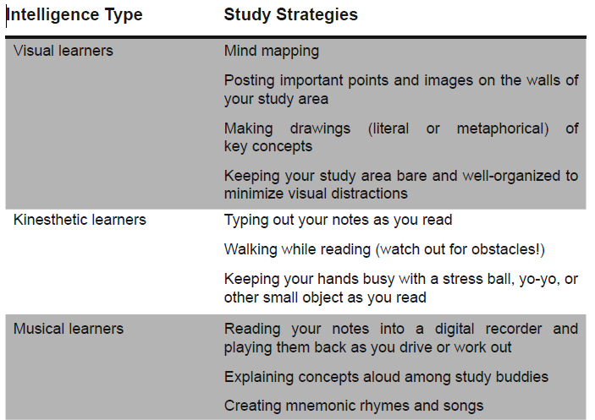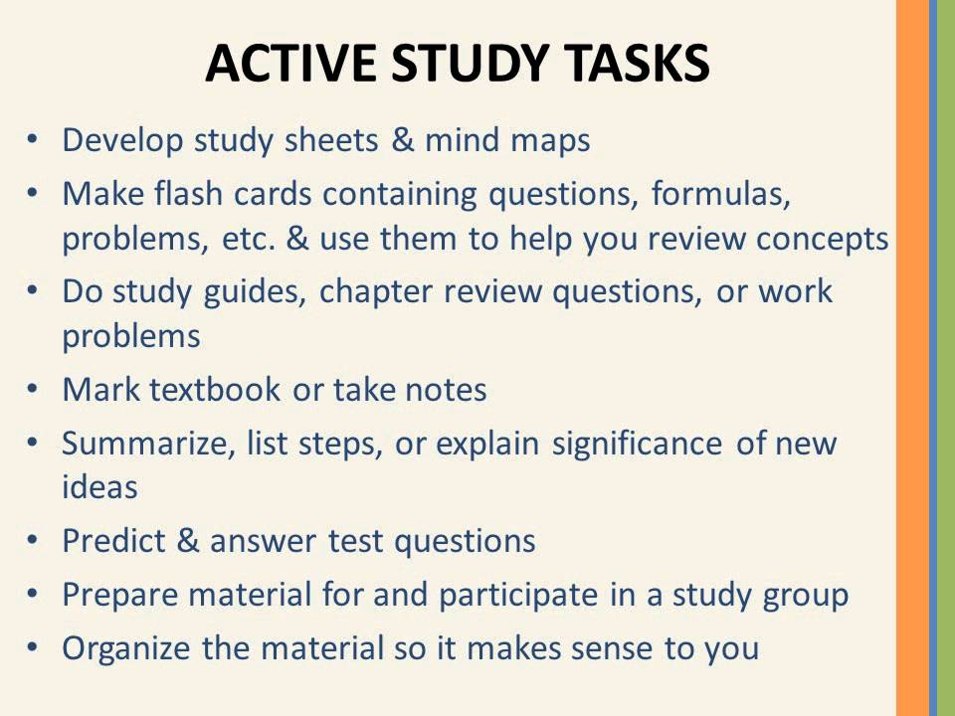

**Preparing for a Math Test**

* **Make a List of Important Concepts/Formulas.**  Review your notes and make a concise list of important concepts and formulas.  Make sure you know these formulas and more importantly how to use them!
* **Rework Homework Problems.**  Do not just read over the homework problems.  Actually rework them.  Writing down the steps will help you to remember them.  Make sure that you try to do the problems without looking at the solutions.
* **Rework Book/Notes Examples.**  Cover up the solutions to book or note examples and try to rework them.  When looking for problems from the book don’t forget that most books have a review section at the end of each chapter that usually contains more problems.
* **Look for Identifying Characteristics in Problems.**  While doing your homework you knew which section it came out of.  This provided some clues as to the solution process.  During an exam you won’t have this to help you.  So, while reviewing your homework look for identifying characteristics that will give you clues on how to identify that kind of problem.
* **Take a Practice Exam.**  Find some problems and treat them like practice test.  Give yourself a time limit and don’t use your notes or book.

**Teacher signature: \_\_\_\_\_\_\_\_\_\_\_\_\_\_\_\_\_\_\_\_\_\_\_\_\_\_\_\_\_\_\_\_\_\_\_\_\_ Date: \_\_\_\_\_\_\_\_\_\_**

**Student signature: \_\_\_\_\_\_\_\_\_\_\_\_\_\_\_\_\_\_\_\_\_\_\_\_\_\_\_\_\_\_\_\_\_\_\_\_\_\_ Date: \_\_\_\_\_\_\_\_\_\_\_\_**

**Parent signature: \_\_\_\_\_\_\_\_\_\_\_\_\_\_\_\_\_\_\_\_\_\_\_\_\_\_\_\_\_\_\_\_\_\_\_\_\_\_\_ Date: \_\_\_\_\_\_\_\_\_\_\_\_**

**Acknowledgement of Ms. Bottomley’s Rules and Procedures for Math Class**

**Please complete both sides and return by September 12th!**

**Parent(s) or Guardian(s)**

Please discuss the above information with your child, then sign and date below. In addition, please check your student's planner at least three times a week and check my teacher page on the school website to stay informed of assignments. If you have any questions or concerns that arise during the school year, please do not hesitate to contact me. By keeping the means of communication open, together, we can ensure that your child will have a successful school year!

--------------------------------------------------------------- --------------

--------------------------------------------------------------- Date

Parent(s)/Guardian Signature

**Student**

I strongly believe that communication is key. If you have any questions regarding class, please talk to me as soon as possible. I am always available during advisory, after school, and by appointment. I am here to help you succeed in my class and in school. Feel free to ask me any questions or state any concerns.

--------------------------------------------------------------- --------------

Student Signature Date

**Personal Information**

1. Do you have access to a home computer?

Printer?

Internet?

1. What are 2 strengths you have in math?
2. What are 2 areas you would like to improve in math?
3. What is something interesting that you are involved in that you would like to share?

**MCj04136380000[1]Student Info for Ms. Bottomley MCj04136380000[1]**

Student’s Name \_\_\_\_\_\_\_\_\_\_\_\_\_\_\_\_\_\_\_\_\_\_\_\_\_\_\_\_\_\_\_\_\_\_\_\_ Period \_\_\_\_\_\_\_\_\_\_\_\_\_\_

**Neatly, write down your parents’/guardians’ names and emails. Please put a \* next to the best email to use for contact.**

Father’s Name\_\_\_\_\_\_\_\_\_\_\_\_\_\_\_\_\_\_\_\_\_\_\_\_\_\_\_\_\_\_\_\_\_\_\_\_

Father’s Email \_\_\_\_\_\_\_\_\_\_\_\_\_\_\_\_\_\_\_\_\_\_\_\_\_\_\_\_\_\_\_\_\_\_\_\_

Mother’s Name\_\_\_\_\_\_\_\_\_\_\_\_\_\_\_\_\_\_\_\_\_\_\_\_\_\_\_\_\_\_\_\_\_\_\_\_

Mother’s Email \_\_\_\_\_\_\_\_\_\_\_\_\_\_\_\_\_\_\_\_\_\_\_\_\_\_\_\_\_\_\_\_\_\_\_\_

**Neatly, write down the following phone numbers (including area code and extension). Please put a \* next to the best number to use for contact.**

Home Phone Number

Father \_\_\_\_\_\_\_\_\_\_\_\_\_\_\_\_\_\_\_\_\_\_\_\_\_\_\_\_\_\_\_\_\_

Mother \_\_\_\_\_\_\_\_\_\_\_\_\_\_\_\_\_\_\_\_\_\_\_\_\_\_\_\_\_\_\_\_\_

Cell

Father\_\_\_\_\_\_\_\_\_\_\_\_\_\_\_\_\_\_\_\_\_\_\_\_\_\_\_\_\_\_\_\_\_\_\_

Mother \_\_\_\_\_\_\_\_\_\_\_\_\_\_\_\_\_\_\_\_\_\_\_\_\_\_\_\_\_\_\_\_\_\_\_\_

Work

Father \_\_\_\_\_\_\_\_\_\_\_\_\_\_\_\_\_\_\_\_\_\_\_\_\_\_\_\_\_\_\_\_\_\_\_\_\_\_\_\_

Mother \_\_\_\_\_\_\_\_\_\_\_\_\_\_\_\_\_\_\_\_\_\_\_\_\_\_\_\_\_\_\_\_\_\_\_\_\_\_\_