Name: ________________________________________ Date: ___________ Period: _____ Rev. 8/19
SUMMATIVE REASSESSMENT FORM
Please fill out this form to reassess your summative assessment. You are expected to follow the steps outlined here for your opportunity to reassess.
Assessment Title: ____________________________________________________Score: _______
Steps to take for the opportunity to reassess:
- The NEWEST score will be recorded in the gradebook, even if the most recent score is lower than the original. Reassessment format may not be the same as the original assessment given.

- Complete this form with parent signature. All areas of this form need to be completed in complete sentences with specific details.

- Students must redo the assessment, within 5 days from when the assessment is handed back, during academic behavioral study hall (ABS). Student will have one day to complete the reassessment.

- All missing/incomplete/LATE assignments must be completed 2 days prior to taking the reassessment.

*Each reassessment will be considered on a case by case basis using teacher’s discretion*
** NO redo/reassessment will be provided during the last week of a quarter. **
*** If any of the above steps are not completed, then the student has chosen to forfeit the opportunity to take the reassessment***
****All assignments must be completed, otherwise reassessment may be forfeited****
1. What steps did you take to prepare for the original assessment (studying)?

__________________________________________________________
__________________________________________________________
2. Why do you believe you earned the score you did? Give three reasons.

__________________________________________________________
__________________________________________________________
__________________________________________________________

Here are some ideas for study tools for daily preparation:
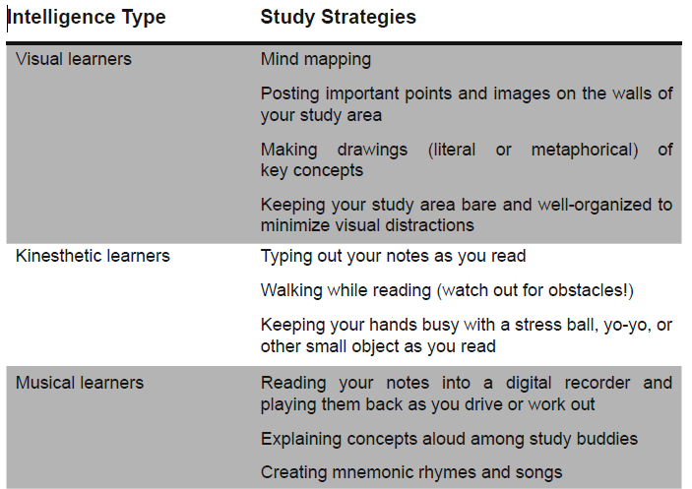
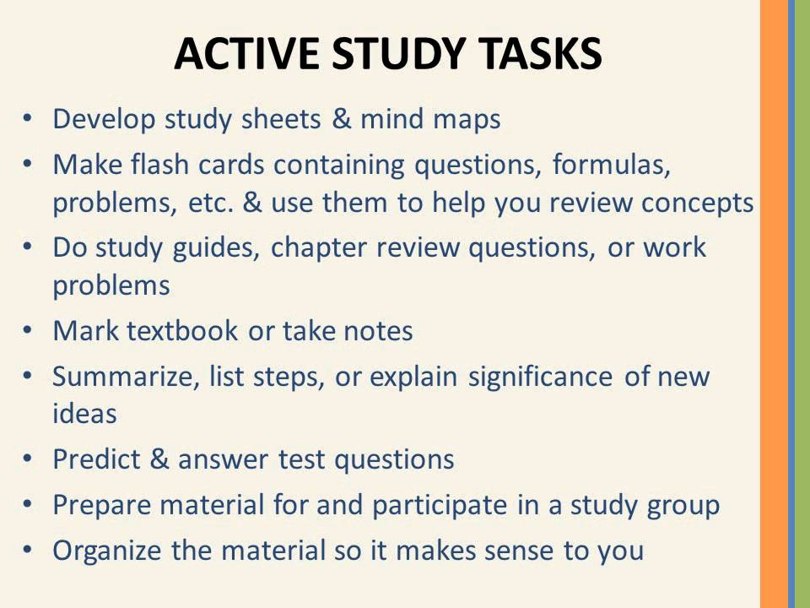

Preparing for a Math Test
- Make a List of Important Concepts/Formulas. Review your notes and make a concise list of important concepts and formulas. Make sure you know these formulas and more importantly how to use them!
- Rework Homework Problems. Do not just read over the homework problems. Actually rework them. Writing down the steps will help you to remember them. Make sure that you try to do the problems without looking at the solutions.
- Rework Book/Notes Examples. Cover up the solutions to book or note examples and try to rework them. When looking for problems from the book don’t forget that most books have a review section at the end of each chapter that usually contains more problems.
- Look for Identifying Characteristics in Problems. While doing your homework you knew which section it came out of. This provided some clues as to the solution process. During an exam you won’t have this to help you. So, while reviewing your homework look for identifying characteristics that will give you clues on how to identify that kind of problem.
- Take a Practice Exam. Find some problems and treat them like practice test. Give yourself a time limit and don’t use your notes or book.

Teacher signature: _______________________________________________ Date: ______________

Student signature: _______________________________________________ Date: ______________

Parent signature: ________________________________________________ Date: ______________

