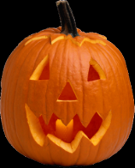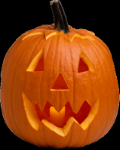
October 2017
Congratulations to

When you show that you are respectful, responsible, or know how to keep yourself safe, you have cool character! In the month of October, you showed cool character outside of school! You were: (select 1 or more)

Respectful! Here is what you did: ____________________________________________________________________________________________________
 Responsible! Here is what you did: ____________________________________________________________________________________________________
Safe! Here is what you did: ____________________________________________________________________________________________________

for showing cool character!
Please fill out the above form or use any sheet of paper from home to let us know the “cool character” that your child displayed at home. After we share your child’s “cool character” with the class, we will put this form in our Kids With Cool Character Raffle that we will have at the end of the month. We will choose one boy and one girl in each month’s raffle who will be entitled to a free trip to our Treasure chest!

