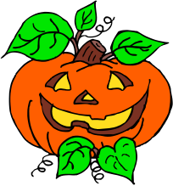
October 2018 Newsletter
Ms. Penny’s Kindergarten
English/Language Arts
The literature which will be introduced in class will incorporate informational texts, adventure stories/fiction, and narrative poems. The students will compare and contrast stories, as well as to discuss the difference between fictional characters and real characters. They will be learning that informational text (literature that is factual) is different from fiction. After reading a book to your child, see if your child can tell you if it is an informational book or a fiction book.

As I read stories in class, I will be helping the students learn to retell the stories. We will be identifying the characters in the story, discussing the setting, and focusing on the events that happen at the beginning of the story, the middle of the story, and at the end of the story. We will also be reviewing the role of an author and of an illustrator. Reviewing these same objectives at home will help to strengthen your child’s reading comprehension skills.

We will continue to focus on the identification of the letters and sounds for students who require extra support. For students who have learned to identify each letter and produce the corresponding sound, they will begin to focus on blending together the letters in consonant-vowel-consonant words. You can help your child at home by encouraging your child to “keep the sounds of a word connected” while sounding out the word, as opposed to separating each individual sound with a pause between each sound. When a child pauses between sounds, as in this word dog: /d/…/o/…/g/, it is often more difficult to assimilate the sounds and produce the word. Help your child to “keep the sounds connected” without any pauses. We will be reviewing various phonograms this month.

Math
The students will strengthen their problem-solving skills by applying their knowledge of sets which contain varying amounts (equivalent sets, sets with more items, and sets with fewer items). They will be collecting and sorting data and compiling it into a graph. You might like to review the concept of more, fewer, equal with your child at home by graphing groups of small objects that you have in your house (i.e., buttons, coins, M& M’s, Skittles, etc). During this month, we will be focusing on recognizing and printing the numerals 0-20, as well as teaching the ordinal (positional) numbers 1-5 (first, second, third, fourth, and fifth).

Science/Social Studies
The students will be learning about Christopher Columbus and the contributions that he made to our country’s history, as well as information associated with the fall season, and fire safety. The children will be learning about the life cycle of a pumpkin, and they will be using a pumpkin to practice their graphing skills and measuring skills.

PBIS/ Displaying ”Cool Character”
Our students will be learning how to maintain a safe environment, both at home and at school. Please continue to help in reinforcing what it means to be respectful, responsible, and safe at home. This is would be very beneficial as our district will continue to focus on these concepts at school!

Fall Festival Parade/Fall Festival Celebration
Our Kindergarten Halloween parade will be on Wednesday, October 31st. Information on the specific time of the parade will be provided closer to this date. All classes will be exiting out the front doors of the school and walking down the sidewalk on the west side of the building. If the weather is inclement, the parade will be canceled.

Please keep in mind that dressing up in a Halloween costume is optional. For those students who are wanting to get dressed up, they may wear their costumes to school. Make-up, if needed, must be applied at home, and it is important to keep in mind that any costume item which resembles any form of a weapon will not be allowed in the school. For safety purposes, full-faced masks are discouraged.


Make sure your child gets some good sleep on the night of October 30th because the students will be going into our gym where they will be enjoying a variety of fun-filled games and events on our Fall Festival Celebration (October 31st)!

Writing
Kindergarten students are required to be able to write an “informational piece”. With assistance, students will gradually learn this process which involves using facts to write about a topic which has been presented. In the beginning of the year, students will start out by copying a specific story starter and adding one or more facts that are also provided. They will be expected to draw a picture that corresponds with this sentence. In the future, the students will learn to use their own words when they are writing. Students will be encouraged to use phonetic spelling (kindergarten spelling) which involves spelling words as they are heard and being able to spell correctly at this level of development is not important. Encouraging your child to write at home will help to strengthen this skill which is expected at the kindergarten level.

Writing is SO much fun!



Can Your Child Answer the Following Questions?
Show your child the three pictures on this page (jack-o-lantern, leaf, apple). How many of the following 8 questions is your child able to answer?

- What is the first letter in the name of each of the pictures?
- What is the last letter in the word “leaf”?
- Which picture is “in between”?
- Which picture is “to the left” of the leaf?
- This leaf comes from a tree. Can you give a word that rhymes with “tree”?
- A pumpkin is orange. A leaf can be brown. An apple can be green. Can you read any of the following colors? red yellow blue
(Students will need to be able to read the color words by the end of kindergarten.)
- Which of the three items weighs the most?
- Which of the three items weighs the least?

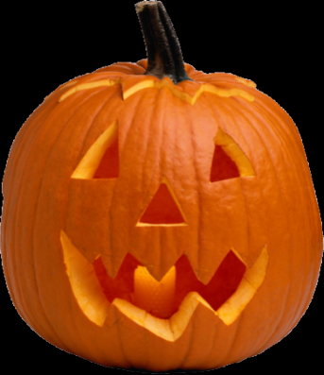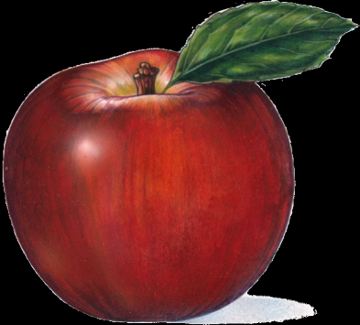

Take the “Kindergarten Spelling” Challenge
If your child can easily print the beginning letter for each of the pictures shown above, ask him/her to listen for every sound that is heard in each word (jack-o-lantern, leaf, apple) and then try to use “kindergarten spelling” to write each word. (Feel free to help your child in sounding out each letter that is heard.) Accurate spelling is NOT to be expected with these more difficult words at the kindergarten level. However, identifying the sounds that can be heard in a word and printing them in the correct order in which they are heard is excellent phonetic practice. When a child uses “kindergarten spelling”, he/she might spell leaf, “lef” or a child might spell apple “apl”. If so, this is terrific!!! Hearing the sounds and printing the letters for those sounds, regardless of the accuracy of the word, is wonderful at this early stage of writing. Please encourage and commend your child for attempting to hear and print as many letters as possible in words.

Special Dates and Events
Please be sure to check your child’s folder for our October calendar. It will provide you with important dates and special events that will be coming up in the future, as well as to inform you on who will be celebrating a special birthday and who will be our next Star of the Week friends.

