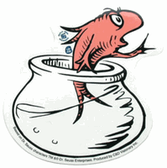
Dr. Seuss’s Birthday Celebration Week

March 2nd is Dr. Seuss’s birthday. In honor of his day, we will be doing many fun activities that correspond with his wonderful stories. We will be reading his books, making rhymes, and creating non-sense words. Below is a list of silly things that the children will be doing this week.

Friday (3/1) The Cat in the Hat Day: The children can wear a favorite hat to school in honor of our friend the Cat in the Hat.

Tuesday (3/5) The Sleep Book: The children can come to school in their pajamas

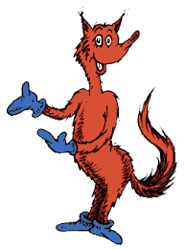
Wednesday (3/6) Wacky Wednesday: The children can come to school with wacky hair and/or dressed in a wacky outfit. We will be looking for wacky things in the classroom.

Thursday (3/7) Fox in Socks Day: The children can come to school in their silly socks or mismatched socks.

Friday (3/8). Bartholomew and the Oobleck: The children will be making Oobleck! Wear old clothes, as Oobleck tends to get messy!

In addition to these activities during the week, we are asking that you complete the writing project on the attached paper. We would like you to take a photo of your child in the craziest place you can find to read your favorite Dr. Seuss book. Please attach the photo in the box and then write about it on the lines.
We look forward to having a wonderful, funderful week!
“You’ve got brains in your head and feet in your shoes,
You can steer yourself any which direction you choose”.
From “Oh, The Places You’ll Go. ~Dr. Suess

