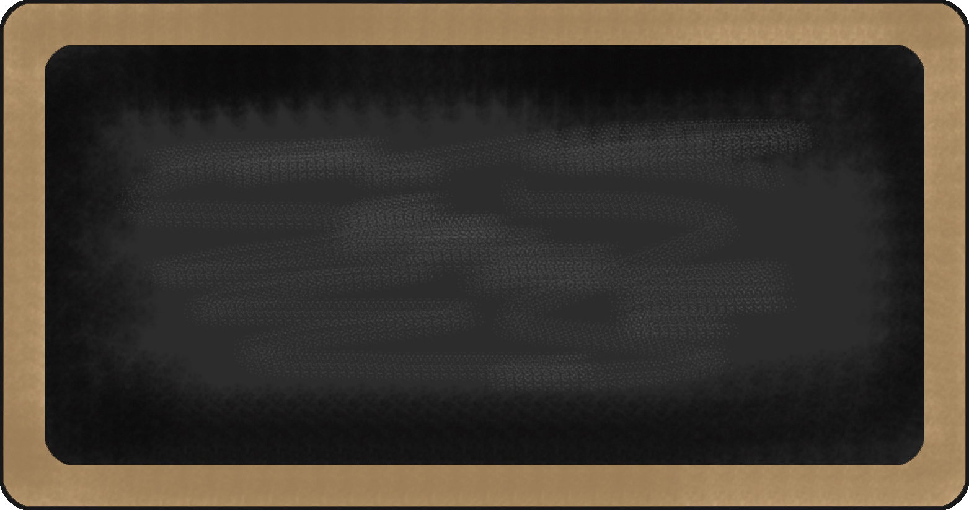
Spelling Words
- bunch
- fruit
- argue
- crumb
- crew
- tune
- juice
- refuse
- truth
- young
- clue
- trunk
- amuse
- suit
- rude
- trust
- dew
- stuck
- rescue
- brush



Upcoming events

10/29- Pumpkin Due
10/31- Halloween Parade and Fall Festival
11/1- Field Trip
11/2- PBIS celebration
11/15- Treat Day
11/19 &11/20- Parent Teacher Conferences

reading | Writing | Language Arts | Math | Science | Social studies
Invasion from Mars | - Informative writing | - verbs | - multiplication |  |   Underground Railroad





Notes from the teacher:
Please read and practice math facts each night!

Please review Halloween expectations sent via email from Mr. Bradley

Please dress accordingly for the outdoor field trip.

Star of the Week:
Nina





Happy Birthday to:
October
Quinn-9
Sophia-18
Ashlee- 20

What we are learning this week:

Contact Information
broach@summithill.org or 815-464-2034


