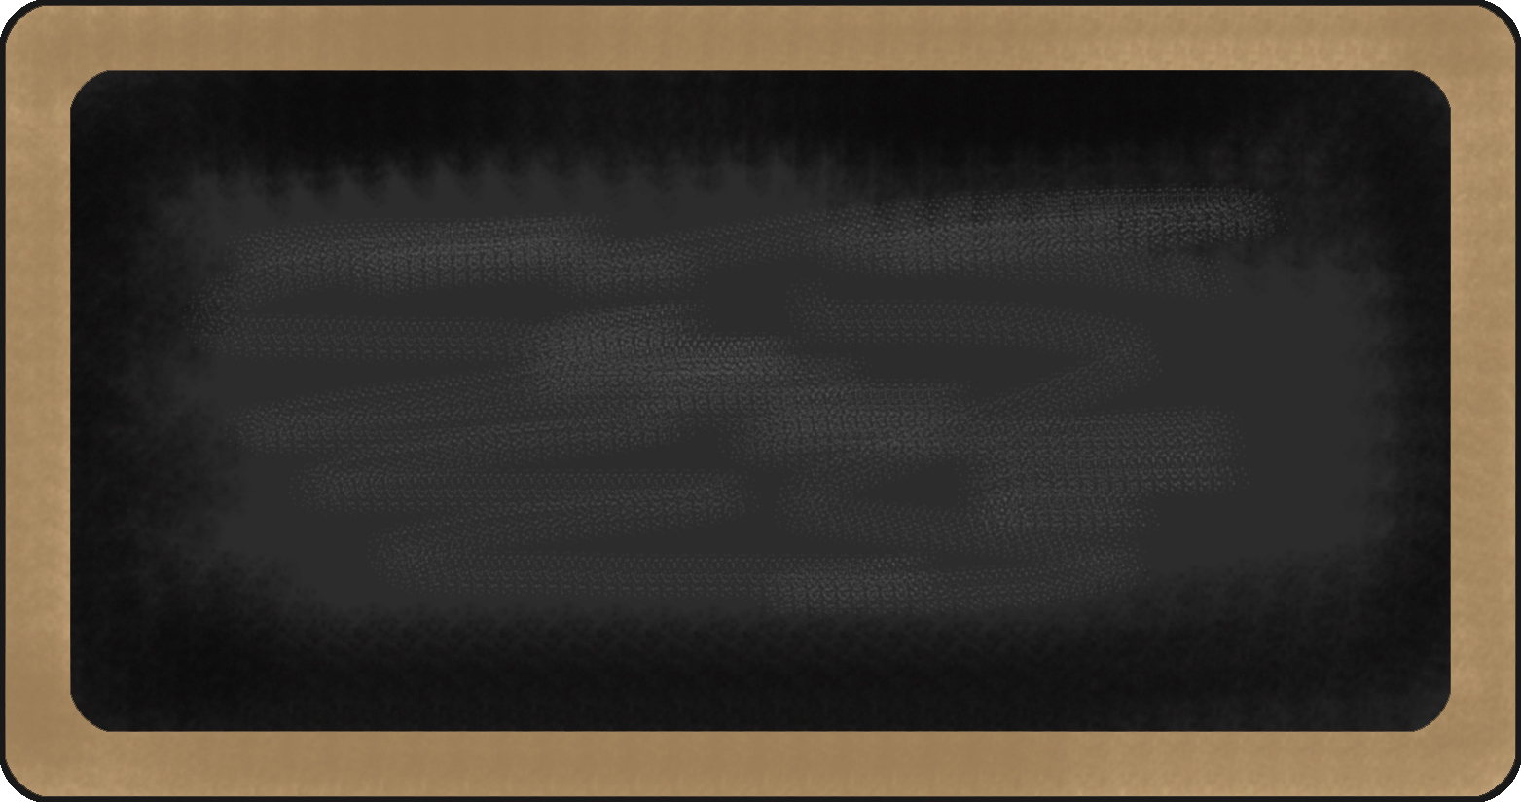
Spelling Words
- dentist
- final
- finish
- narrow
- shelter
- ahead
- corner
- hollow
- divide
- famous
- recent
- silver
- capture
- cabin
- dinner
- minus
- minute
- value
- reward
- broken



Upcoming events

11/15- Treat Day
11/15- Book Fair
11/19 &11/20- Parent Teacher Conferences
11/21-11/25- Break
11/28- Eagle’s Nest
11/29- Hot Lunch

reading | Writing | Language Arts | Math | Science | Social studies
I Could Do That! | - Informative writing | - negatives | - multiplication | Sense receptors |   Underground Railroad





Notes from the teacher:
Please read and practice math facts each night!
I look forward to our upcoming conferences!

Star of the Week:
Carrigan





Happy Birthday to:
November

What we are learning this week:

Contact Information
broach@summithill.org or 815-464-2034


