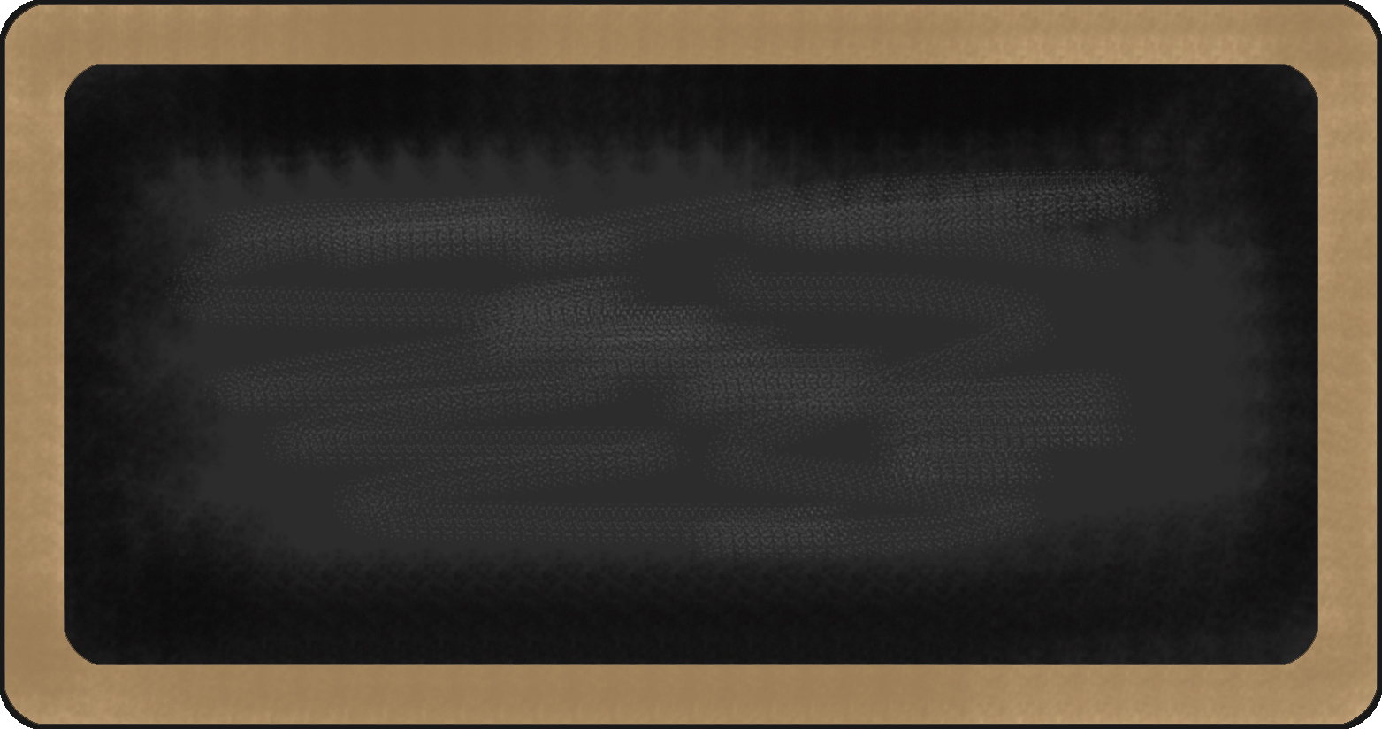
Spelling Words
- bloom
- cookbook
- tool
- shampoo
- put
- wool
- stool
- proof
- prove
- group
- brook
- foolish
- bush
- crooked
- booth
- raccoon
- hook
- groom
- roof
- soup

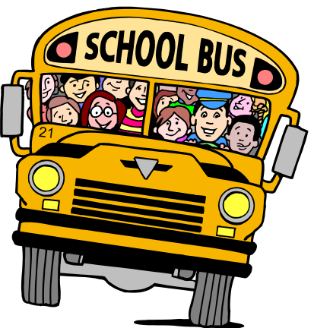

Upcoming events

12/3- NWEA Reading
12/7- NWEA Math
12/12- Winter Program
12/18- SHJH Tour
12/19- Eagle’s Nest
12/21- Last Day before break

reading | Writing | Language Arts | Math | Science | Social studies
Coming Distractions | - Informative writing | - Verb Tenses | - multiplication | Sense receptors |   Westward Expansion



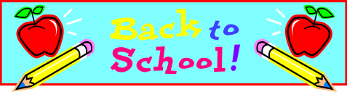

Notes from the teacher:
Please read and practice math facts each night!

Star of the Week:
Zion

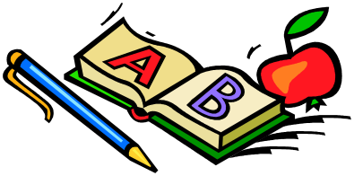



Happy Birthday to:
December

Andrew-9

What we are learning this week:

Contact Information
broach@summithill.org or 815-464-2034


