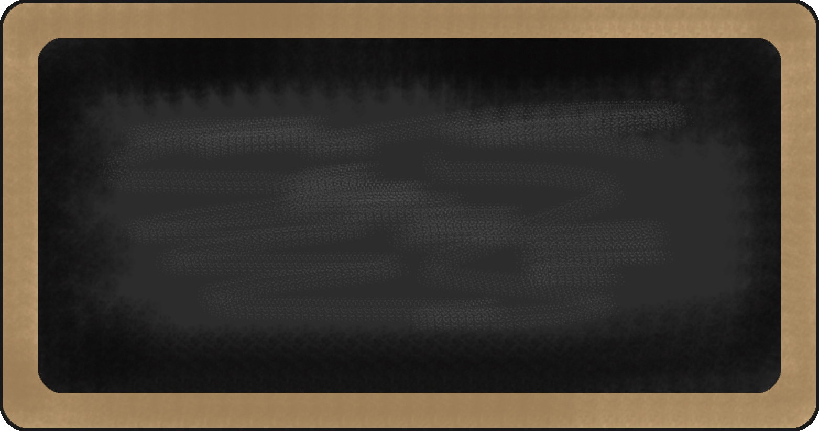
Spelling Words
- wiped
- covered
- mapped
- pleasing
- slipped
- putting
- traveled
- seeking
- visiting
- mixed
- shipped
- phoning
- offered
- smelling
- hiking
- checking
- fainted
- landed
- becoming
- wandering

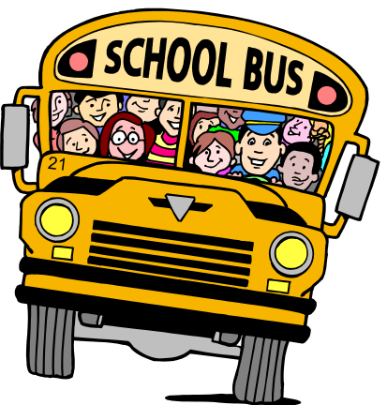

Upcoming events

3/14- Treat Day
3/20- Eagle’s Nest
3/21- Hot Lunch
3/25-3/31- SPRING BREAK

reading | Writing | Language Arts | Math | Science | Social studies
Simile and metaphors | - Persuasive | - Modal auxiliaries | - Factors and multiples | Rock Patterns |   Westward Expansion





Notes from the teacher:
Please read and practice math facts each night!

Star of the Week:

Andrew





Happy Birthday to:
March
Gigi-7
Aidan-17
Kinsley-18

What we are learning this week:

Contact Information
broach@summithill.org or 815-464-2034


