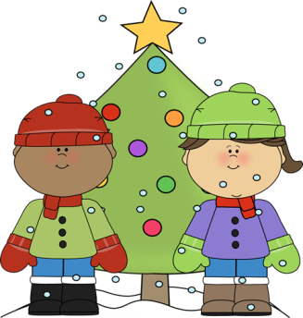**December**



**Birthdays and Other Important Dates**

**Holiday Shoppe this week! Please send money in the given envelope with a list of who you child is to purchase for and how much they should spend on that person**

**- Reading quiz and spelling quiz on Friday**

* One fun way to practice spelling or sight words is making “frozen sand” with white sand and glitter in a box and having children use a pencil to write their words in the sand

Math

This week we are finishing comparing numbers and chapter 2

CH 2 test at the end of the week!

Spelling Words: /all/

ball tall

fall wall

call all

hall

mall BONUS

stall green

small red

Weekly Theme: Fairy Tales

Until the winter break we will working on understanding fairy tales and comparing different stories.

We will also be working on writing our own version of the Gingerbread Man.

Phonics:

Focus is on “glued sounds”- sounds that are chunked together such as /all/

Mrs. Carda’s Weekly Newsletter

Week of Dec. 4th