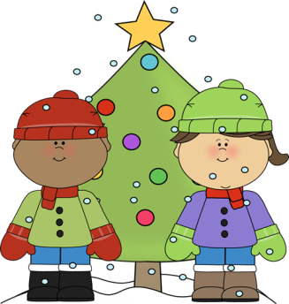**December**



**Important Dates**

**Holiday program is Thursday!**

* One fun way to practice spelling or sight words is making “frozen sand” with white sand and glitter in a box and having children use a pencil to write their words in the sand

Math

We will be starting Ch.3 and working on double facts in addition.

Spelling Words: /ing/

bring ding

ping BONUS

ring day

sing winter

wing

zing

thing

king

swing

ding

Weekly Theme: Fairy Tales

This week our focus will be on “fractured” fairy tales.

We will also be working on writing our own version of the Gingerbread Man.

Phonics:

Focus is on “glued sounds”- sounds that are chunked together such as /ing/

Mrs. Carda’s Weekly Newsletter

Week of Dec. 11th