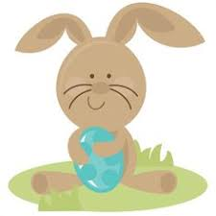 **April**





IMPORTANT DATES/REMINDERS:

Thursday- Spelling Test/ Sunglasses Day

Friday- No School- Spring Holiday

Weekly Theme:

We will be reading More Baby Animals and will be talking about the main idea and details of informational text.

Phonics: Our focus will be on the /a/ and /e/ short vowel sounds

Spelling Words

1. cat 2. map

3. jam 4. pen

5. red 6. bed

1. b band
2. hand
3. land
4. sand
5. think
6. sink
7. pink
8. wink
9. link
10. rink

BONUS words

1. blink
2. bland
3. and
4. hand
5. land
6. sand
7. think
8. sink
9. pink
10. wink
11. link
12. rink

BONUS words

1. blink
2. bland

Mrs. Carda’s Weekly Newsletter 1st grade

Week of April 12th