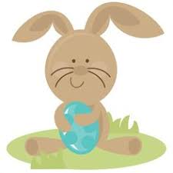 **April**





IMPORTANT DATES/REMINDERS:

Monday-No School-Spring Holiday

Friday- Spelling test/Reading Assessment

Weekly Theme:

We will be reading How Do They Swim and learning about comparing two different animals. We will also be learning about characteristics/traits to describe animals.

Phonics: Our focus will be on the /i/ and /o/ short vowel sounds

Spelling Words

1. mit 2. bin

3. sip 4. cot

5. rod 6. dog

1. b band
2. hand
3. land
4. sand
5. think
6. sink
7. pink
8. wink
9. link
10. rink

BONUS words

1. blink
2. bland
3. and
4. hand
5. land
6. sand
7. think
8. sink
9. pink
10. wink
11. link
12. rink

BONUS words

1. blink
2. bland

Mrs. Carda’s Weekly Newsletter 1st grade

Week of April 22nd