**Maya Videos**

[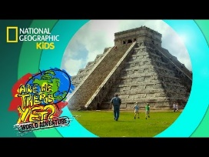](https://www.youtube.com/watch?v=udYpZn-TEg8) [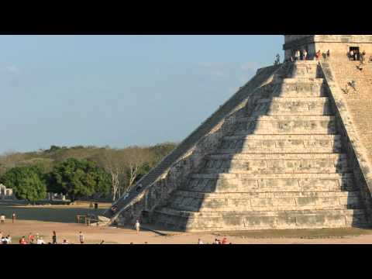](https://www.youtube.com/watch?v=86F10IrvVus) [](https://www.youtube.com/watch?v=RXgrcpmFXt0)

**Aztec Videos**

[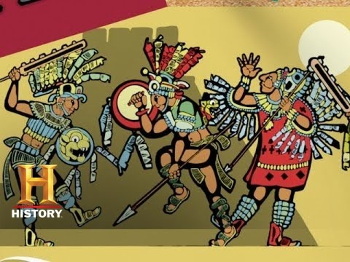](https://www.youtube.com/watch?v=i3kWJfkqT0g) [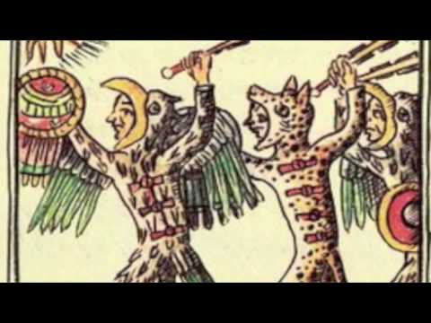](https://www.youtube.com/watch?v=-4W4PUdtOE0)

**Inca Videos**

[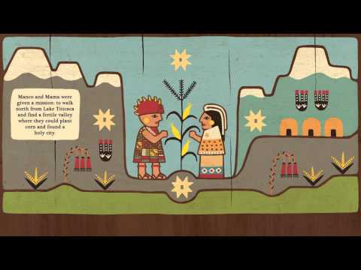](https://www.youtube.com/watch?v=GdXTwUTsni0) [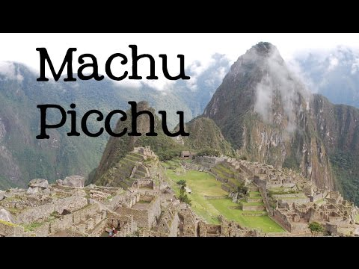](https://www.youtube.com/watch?v=5cVSWA37xiI) [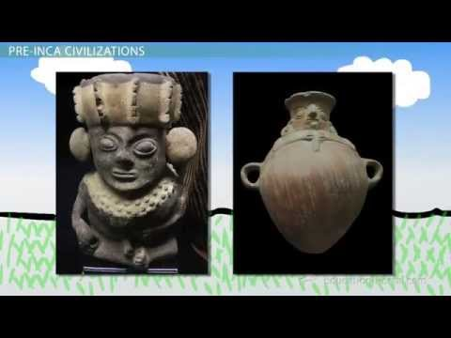](https://www.youtube.com/watch?v=s_xK1wfixHY)