Great Britain vs The 13 Colonies

Click on the link below each picture to learn how the British Army compared to the Continental Army during the American Revolution. Read each article and complete your T chart to show their differences and similarities.

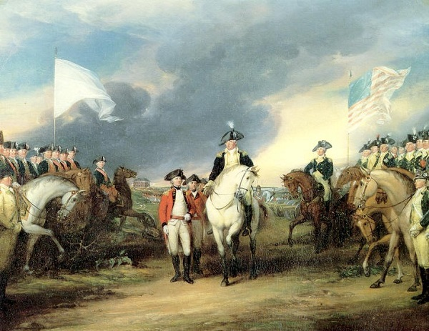
https://historyofmassachusetts.org/british-army-revolutionary-war/

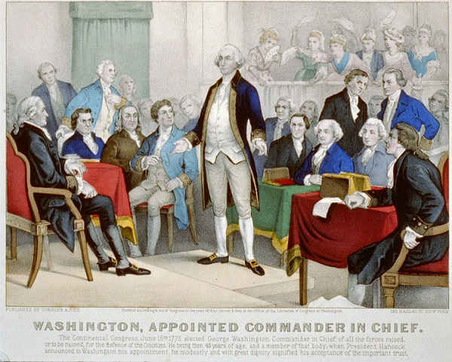
https://historyofmassachusetts.org/continental-army-revolutionary-war/

