FOSSIL OBSERVATION WORKSHEET
Use the pictures of these 4 fossils for the “Fossil Observation” worksheet. Each link will bring you to a website that can help with your description of each fossil.
Fossil #4
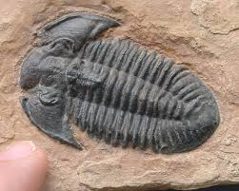
https://www.emaze.com/@AQRFWOFQ/cast-fossils
https://ourpastimes.com/cast-fossils-8154956.html

Fossil #3
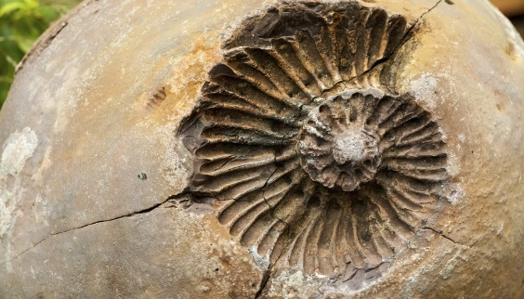
https://sciencing.com/mold-cast-fossils-6556194.html

Fossil #2
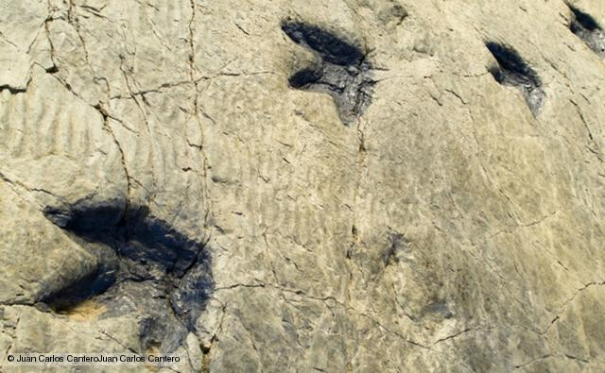
http://www.ucmp.berkeley.edu/science/trackways/index.php

Fossil #1
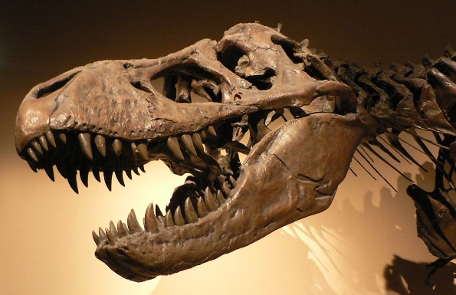
https://www.amnh.org/dinosaurs/dinosaur-bones/

