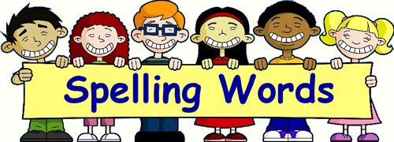
NAME_______________________________________ #________________
Weekly Spelling Homework
Your goal is to earn 20 points by completing any combination of the activities below. Some activities are worth five points, while others are worth ten points. Please lightly color the boxes you completed and staple your work to the back of this contract (with the exception of the activity that requires a parent signature). Please return the contract with all work attached by Thursday _________________.
Five Point Activities
3x Each  Write each of your spelling words correctly three times each. | ABC Order  Write your spelling words in ABC order. | 3x Each Cursive  Write each of your spelling words correctly three times each in your best cursive writing.
Big and Tall Words  Write each of your spelling words in all capital letters. Then write each word again in all lowercase letters.  (ex. BOAT boat) | Count it Out  Write each of your spelling words neatly and then divide each word into syllables. You may use a dictionary to help you.  (ex. scarecrow scare-crow) | Scrambled Words  Have an adult scramble up your spelling words on a piece of paper. Then try to unscramble each word and write it correctly. (ex: lypa play)
Neon Words  Write each of your spelling words neatly. Then highlight all of the vowels in yellow. After you have highlighted all the vowels, go back and highlight the consonants in a different color. | Type ‘Em Up  Type each of your spelling words on the computer. Change the font for each word. | Spelling City  Go to www.spellingcity.com/karenjean and click on this week’s list. Choose one of the online activities to practice your spelling words.  Parent Signature Required  _______________________________

Ten Point Activities
Broadcaster Spelling  Pretend you are a newscaster, weather person or reporter and use your spelling words to write a news report. You may write multiple news reports using only a few words until all of your words have been used at least once. | Comic Strip Spelling  Use your spelling words to write and illustrate a comic strip. You may use all your spelling words in one comic strip or you may write and illustrate multiple comic strips until all your spelling words have been used.
Sentence Spelling  Use each of your spelling words in a sentence that shows you understand its meaning. Underline the spelling word. | Summer/Fall Scene  Draw a picture of a summer or fall scene and hide your spelling words in your drawing. Don’t forget to make it colorful and detailed for full credit!

