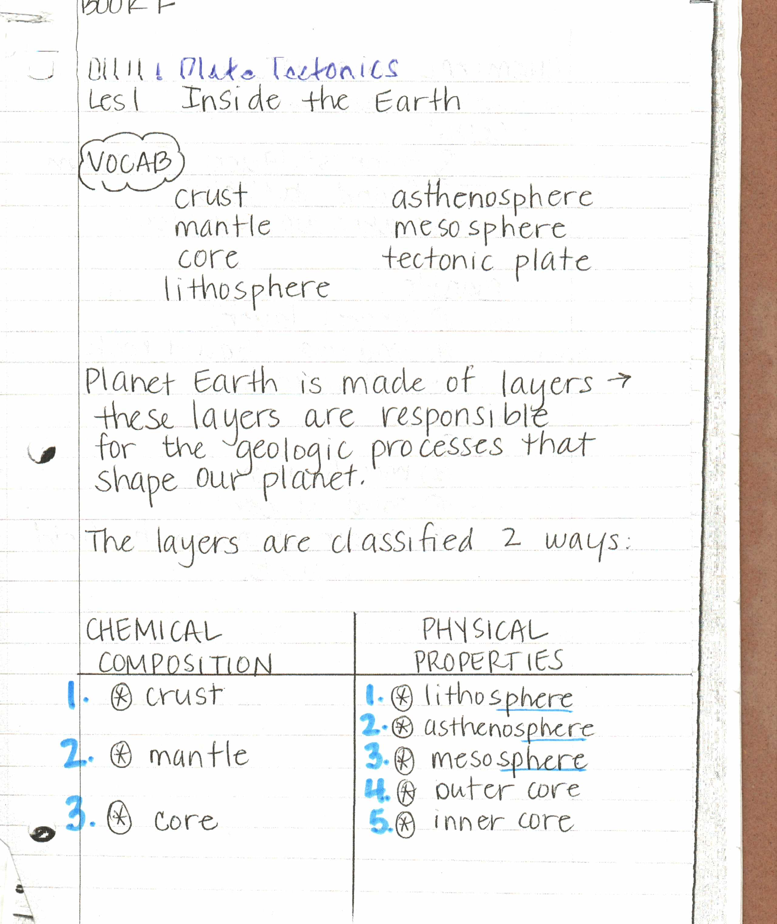

BOOK F

CHAPTER 4 – PLATE TECTONICS

LESSON 1 – INSIDE THE EARTH