Name:_____________________________Class Period:____________Date:__________
Book F - CH 4
Lesson 3 Review

Define the three main types of plate boundaries: Make sure to include the type of motion between the plates as well as the geologic feature/event that results from the motion.

1. Convergent:

At a convergent boundary, two tectonic plates collide. There are three sub-groups of convergent boundaries – it depends on what two types of tectonic plates are colliding; continental plates, oceanic plates, or a collision between a continental plate and an oceanic plate. Geologic features that are formed from these plate collisions depend on which two plates are colliding, and can include mountain ranges, volcanoes and deep ocean trenches.

2. Divergent:

At a divergent boundary, two tectonic plates are moving away from one another. The plates are separating. If continental plates are separating, the geologic feature that is formed is called a rift valley. The rift valley usually does not fill up with any magma – it is simply a large break in the continental crust that can stretch for thousands of miles. If oceanic plates are separating, the geologic feature is called a mid ocean ridge. At mid ocean ridges, magma does rise to the surface, creating new sea floor.

3. Transform:

At transform boundaries, tectonic plates slide past one another. At these boundaries, earthquakes are common – either on land or in the ocean. Earthquakes occur because as the plates are sliding past each other, friction is building up. Since the edges of the plates are jagged and uneven, the plates sometimes get stuck to each other as they are trying to move past each other. The grinding and jagged motion as the plates move past one another is what causes an earthquake.

4. What is subduction, and what causes this process to occur?

Subduction is the term used to describe the motion of one plate moving under another plate. Subduction occurs at some convergent boundaries ( when plates are moving towards each other). One plate will slide under another plate because one plate is heavier and denser than the other plate.

The heavier weight is caused by an increase in density. Oceanic crust is denser and heavier than continental crust, because the weight of the water is compacting the oceanic crust. Also, some types of oceanic crust is heavier than other types of oceanic crust, depending on the age of the oceanic crust.

Subduction happens at two types of convergent boundaries – oceanic-oceanic convergent boundaries and continental-oceanic convergent boundaries.

5. The three special types of convergent boundaries are listed in the table below. For each type of convergent boundary, provide the following information:

- the specific motion that occurs between the plates
- the geologic feature/event that results from the movement of the plates

continental – continental | oceanic – oceanic | continental – oceanic
MOTION: two tectonic plates made of continental crust collide  GEOLOGIC FEATURE: mountain ranges are formed | MOTION: two tectonic plates made of oceanic crust collide  subduction occurs (sometimes) because one plate contains oceanic crust that is heavier and denser than the other oceanic crust (crust is ‘recycled’)  GEOLOGIC FEATURE: deep ocean trenches are formed; underwater volcanoes can also form - from subduction  *when plates do not subduct, underwater mountain ranges are formed | MOTION: two tectonic plates collide – one is oceanic crust and one is continental crust  subduction occurs because the oceanic crust is heavier and denser than the continental crust (crust is ‘recycled’)  GEOLOGIC FEATURE: volcanoes on land can form at this boundary

6. Geologic features created from plate boundaries can be seen on the surface of the planet as well as deep in the ocean.

For the following plate boundaries, describe the geologic feature OR geologic event that is created on land and the geologic feature that is created deep in the ocean as a result of the plate motion.

DIVERGENT BOUNDARY: GEOLOGIC FEATURE

on land | in the ocean
RIFT VALLEY | MID OCEAN RIDGES  **new SEA FLOOR forms

TRANSFORM BOUNDARY: GEOLOGIC EVENT

on land | in the ocean
EARTHQUAKES | EARTHQUAKES  that can cause TSUNAMIS

7. Heat can have an effect the density of a material. This concept is used as a possible explanation for plate motion. Explain how heat and density can be used as a possible explanation for plate tectonics.

The pieces of the lithosphere (plates) move on top of the asthenosphere. To explain the movement of the plates, we need to look at the asthenosphere. In the asthenosphere, rock is in a stretchable solid state. Within this layer, temperatures also change – near the top of the asthenosphere, it is cooler. Deeper in the asthenosphere, the temperatures greatly increase.

Temperature affects the density of material – as the temperature of the material increases, the density of the material decreases. As temperatures cool down, the density of the material increases, and the material becomes heavier.

TEMPERATURES DECREASE (COOL DOWN) = DENSITY INCREASES (MATERIAL IS HEAVY)
TEMPERATURES INCREASE (HEAT UP) = DENSITY DECREASES (MATERIAL IS LIGHT)

The heat from the interior of the Earth heats up the rock material within the asthenosphere and the material rises. As it rises through the asthenosphere, it cools and sinks lower in the asthenosphere.

This cycle of heating and cooling creates a circulation pattern called a CONVECTION CELL within the asthenosphere. The force from this circular movement is what causes the tectonic plates found in the lithosphere to move.

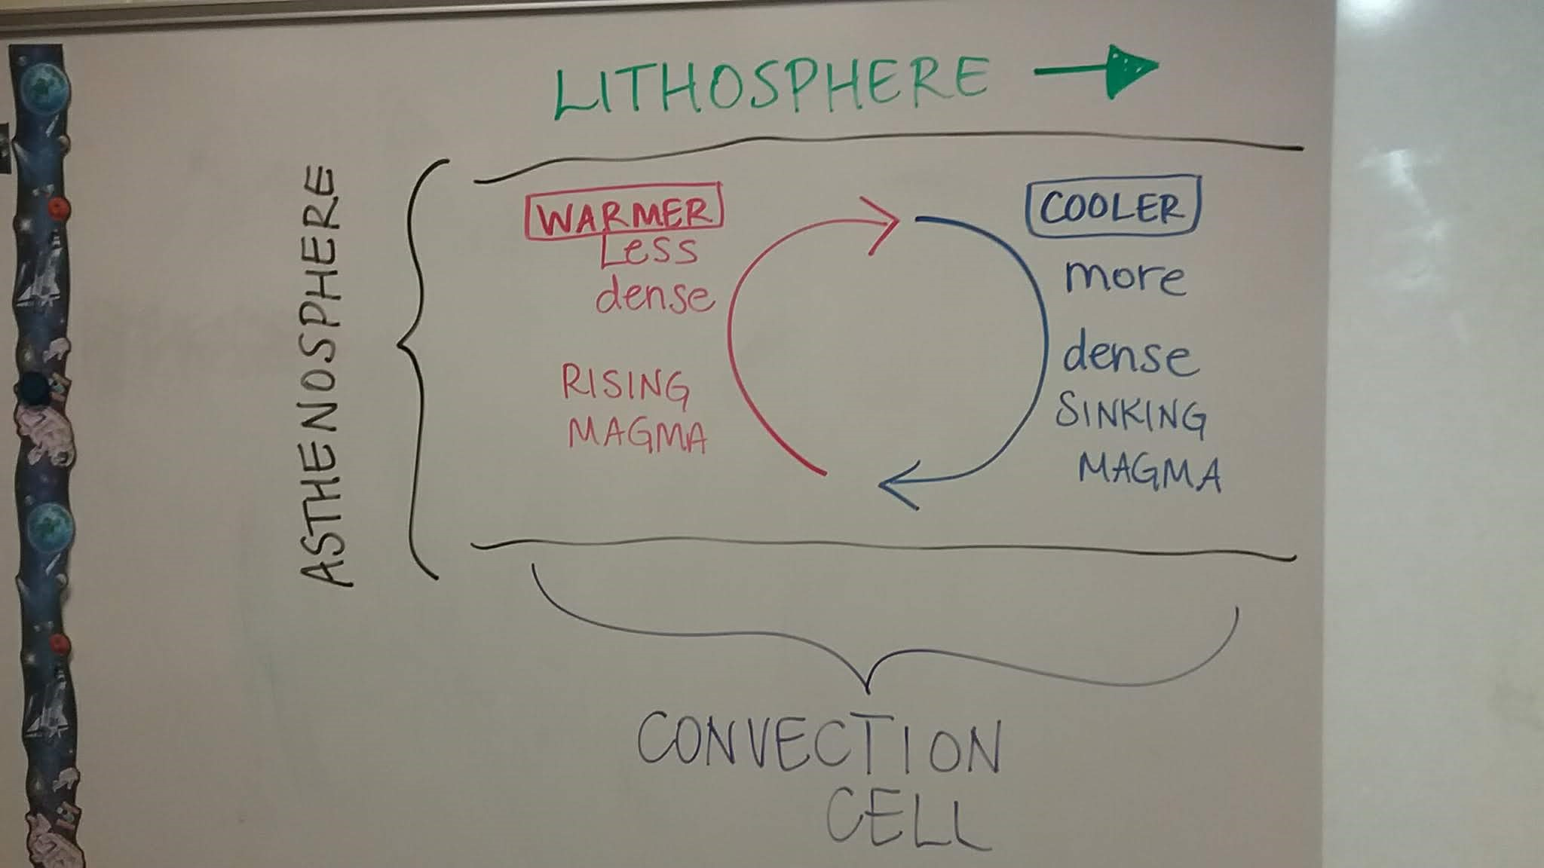

This complete diagram is an acceptable answer for #7

