A. 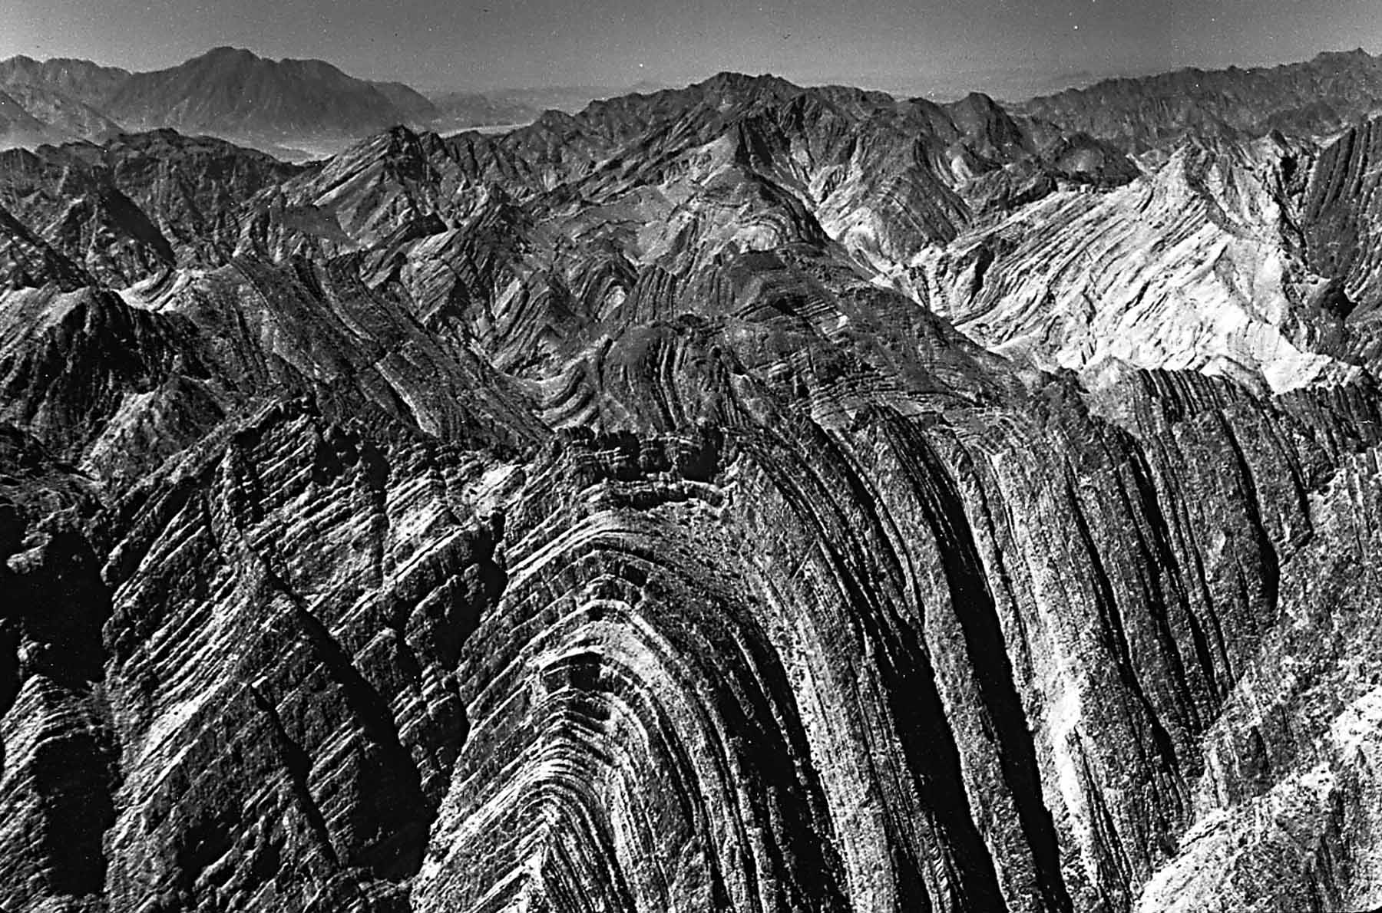

B. 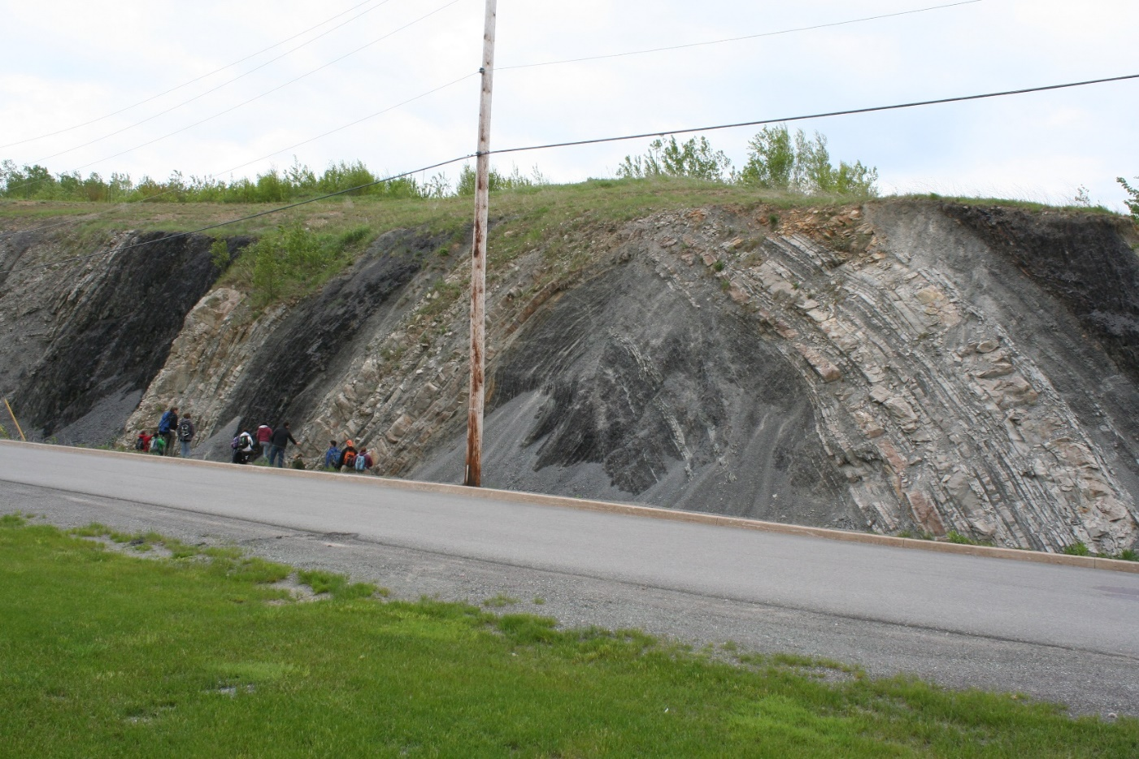

C. 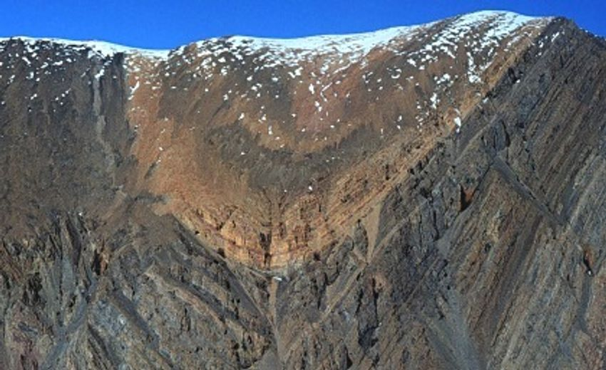

D.

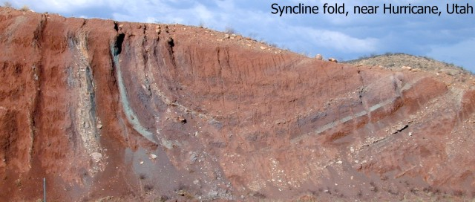

E.
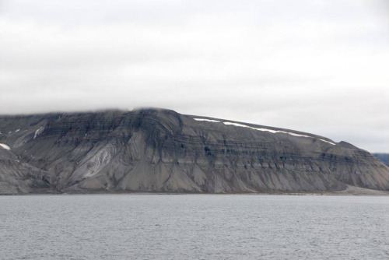

F.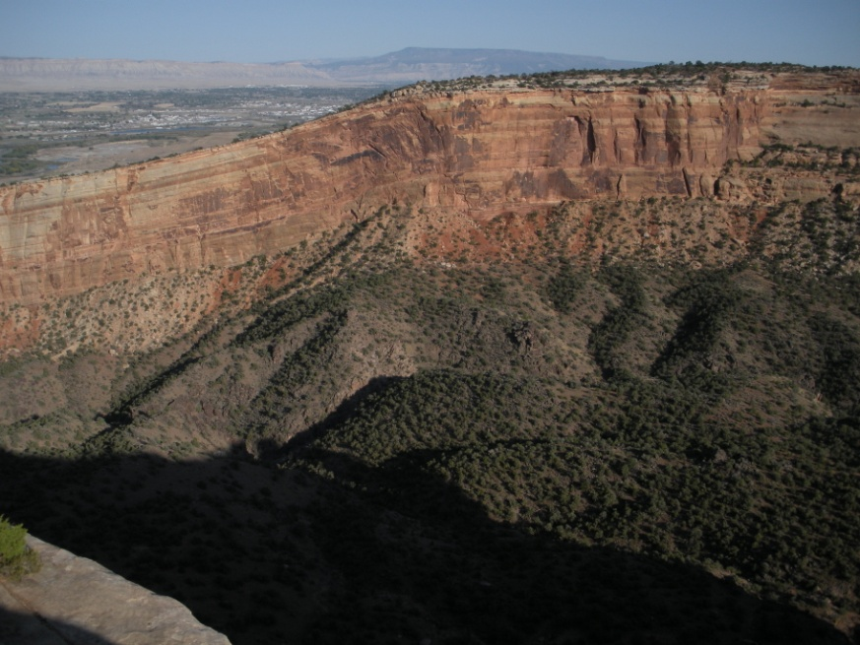

ANSWERS:
PICTURE | FORCE | BOUNDARY | NAME OF FOLD
A | COMPRESSION | CONVERGENT | ANTICLINE- UPWARD FACING ARCH
B | COMPRESSION | CONVERGENT | ANTICLINE-UPWARD FACING ARCH
C | COMPRESSION | CONVERGENT | SYNCLINE-DOWNWARD FACING ARCH
D | COMPRESSION | CONVERGENT | SYNCLINE-DOWNWARD FACING ARCH
E | COMPRESSION | CONVERGENT | MONOCLINE-FLAT END, SLOPE, ANOTHER FLAT END
F | COMPRESSION | CONVERGENT | MONOCLINE – FLAT END, SLOPE, ANOTHER FLAT END

