A.
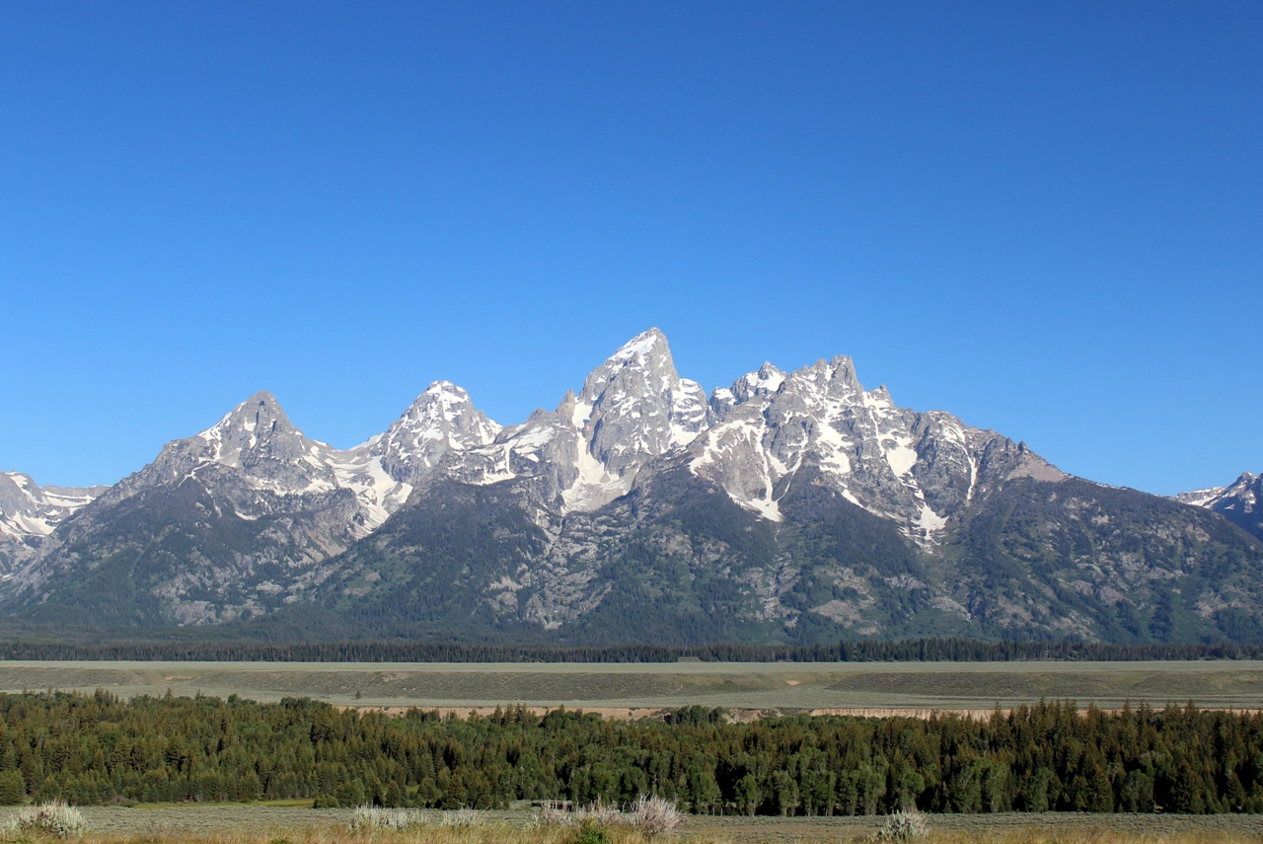

B.
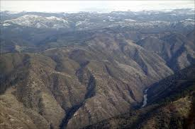

C.
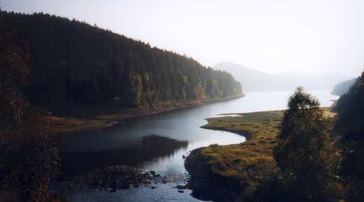

D
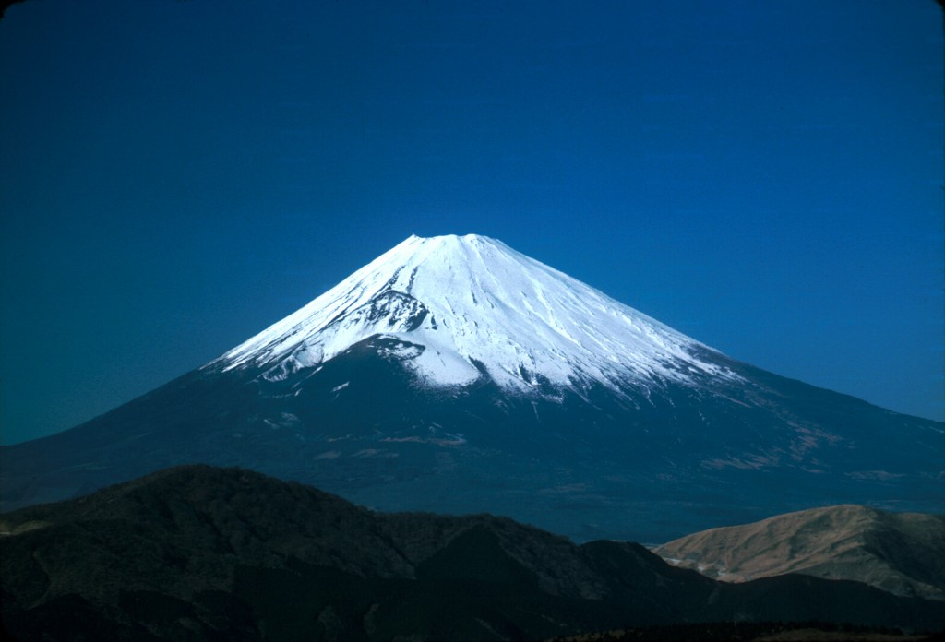
E
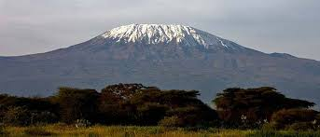
F
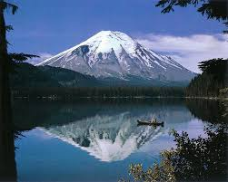

G.
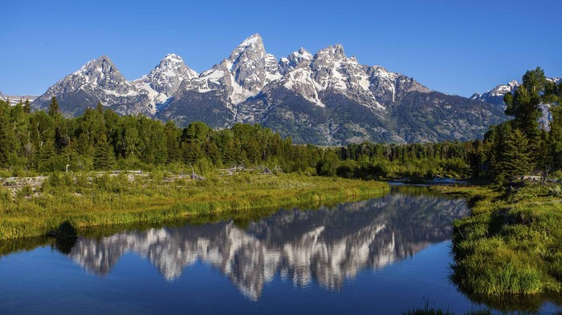

H.
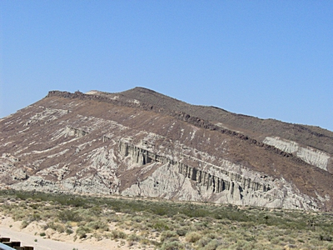

I.
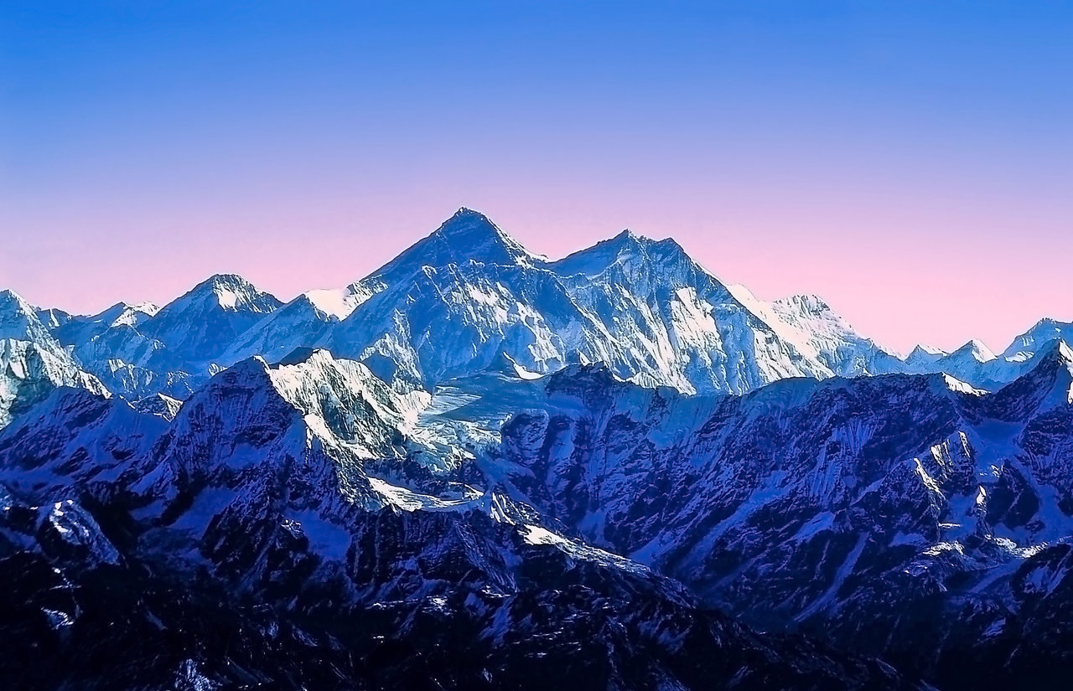

J.
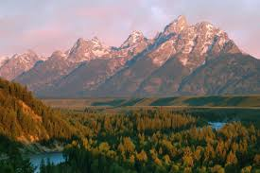

ANSWERS:

PICTURE | FORCE | BOUNDARY | NAME OF MOUNTAIN TYPE | DESCRIPTION
A | compression | Convergent;  Continental-continental | fold | jagged pointy peaks; very tall
B | tension | divergent | fault block | sloped or slanted appearance; all mountains look like they are tilted in the same direction
C | tension | divergent | fault block | sloped or slanted appearance; all mountains look like they are tilted in the same direction
D | compression | convergent; (continental;oceanic)  at subduction zones | volcanic | one single structure; cone shaped
E | compression | convergent; (continental;oceanic)  at subduction zones | volcanic | one single structure; cone shaped
F | compression | convergent; (continental;oceanic)  at subduction zones | volcanic | one single structure; cone shaped
G | compression | Convergent;  continental-continental | fold | jagged pointy peaks; very tall
H | tension | divergent | fault block | sloped or slanted appearance; all mountains look like they are tilted in the same direction
I | compression | Convergent;  Continental-continental | fold | jagged pointy peaks; very tall
J | tension | divergent | fault block | sloped or slanted appearance; all mountains look like they are tilted in the same direction

