Name:______________________________Class Period:_____________Date:_________

Book F
Chapter 4 Lesson 4 Review

All answers should be written in complete sentences on looseleaf paper.

1. For each pair of terms explain how the pair of terms is alike and how the pair of terms is different. Remember, you need to provide information about each term as you explain the similarity and the difference.

A. compression and tension

SIMILARITY:
Compression and tension are both types of forces.

DIFFERENCES:
Compression is a force that occurs mostly at convergent boundaries. This type of force will cause the rocks to compress. Mountain formation is a result of compression.

Tension is a force that occurs at divergent boundaries. This type of force will stretch and pull the rocks apart. Rift valleys and mid ocean ridges (sea floor spreading) are two geologic formations that are created as a result of tension.

B. uplift and subsidence

SIMILARITY:
Uplift and subsidence are both types of vertical movement in the crust of Earth.

DIFFERENCES:
Uplift is the rising of crust – mountain ranges are created from uplift, and new rock surfaces are exposed when uplift occurs. Uplift can occur at convergent boundaries where compression takes place.

Subsidence is the sinking of crust – rift zones are places where the crust can sink or fall. Subsidence can occur at divergent boundaries where tension is pulling plates apart.

C. reverse fault and normal fault

SIMILARITY:
Both are types of faults – rocks break at a fault due to the pressure on the rock.

DIFFERENCES:
Reverse faults form as a result of compression. These faults normally form at convergent boundaries. In a reverse fault, the hanging wall moves UP.

Normal faults form as a result of tension. These faults normally form at divergent boundaries. In a normal fault, the hanging wall moves DOWN.

2. Describe the three main types of folds. For each type, please include an illustration / diagram. Make sure your illustration / diagram is labeled with the correct fold.

The force required to fold rocks is a compression force, usually at convergent boundaries. Rocks can either fold under horizontal stress or vertical stress.

Horizontal stress: anticlines and synclines will be present.

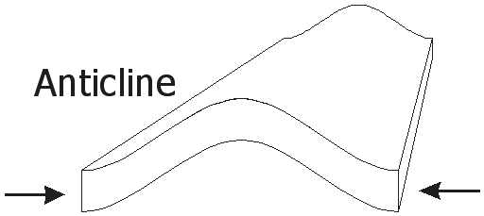 Anticlines have upward arching folds

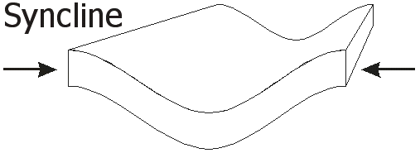Synclines have downward arching folds

Vertical stress: monoclines will be present.

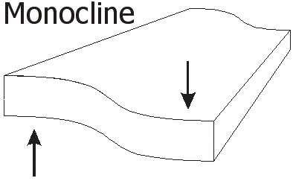Monoclines have vertical stress and both edges of the fold are
horizontal. It is similar to a “step”.

3. Describe the three types of faults. When describing the faults, make sure to include:
- the force associated with the fault and the type of plate motion
- the movement of the hanging wall and foot wall

normal fault | reverse fault | strike-slip fault
1. force: tension  2. plate movement: plates move apart (divergent boundaries)  3. hanging wall moves DOWN | 1. force: compression  2. plate movement: plates move together (convergent boundaries)  3. hanging wall moves UP | 1. force: horizontal force – no compression or tension  2. plate movement: plates move past each other (transform boundaries)  3. there is no up or down hanging wall /foot wall movement ;these blocks of rock move side by side

4. Make a chart of the three types of mountains. Include the following information:
-brief description of what the mountain looks like
-plate motion that created the mountains
-specific example/name of each type of mountain

FOLD MOUNTAINS | FAULT BLOCK MOUNTAINS | VOLCANIC MOUNTAINS
*large mountain ranges; jagged peaks are sometimes present  *form at continental-continental convergent boundaries  *force: compression | *tilted appearance  *form at divergent boundaries  *force: tension | *single standing mountain  *form at subduction zones;  *convergent boundaries-continental -oceanic  molten magma collects in a pool under the crust and is forced to the surface (eruption)  *force: compression

5. If a fault occurs in an area where rock layers have been folded, which type of fault is it likely to be? Explain and support your answer.

When rock layers are folded, this is caused by a compression force. The type of fault that is created from compression forces is a reverse fault – where the hanging wall moves UP. See illustration on pg 114 or use your paper models for reverse faults.

6. Would you expect to see a folded mountain range at a mid ocean ridge? Explain and support your answer.

Folded mountain ranges form at convergent boundaries – where the tectonic plate are moving towards each other. Mid ocean ridges are formed at divergent boundaries – where the tectonic plates are moving away from each other. Fault block mountains or even volcanic mountains can form at mid ocean ridges.

