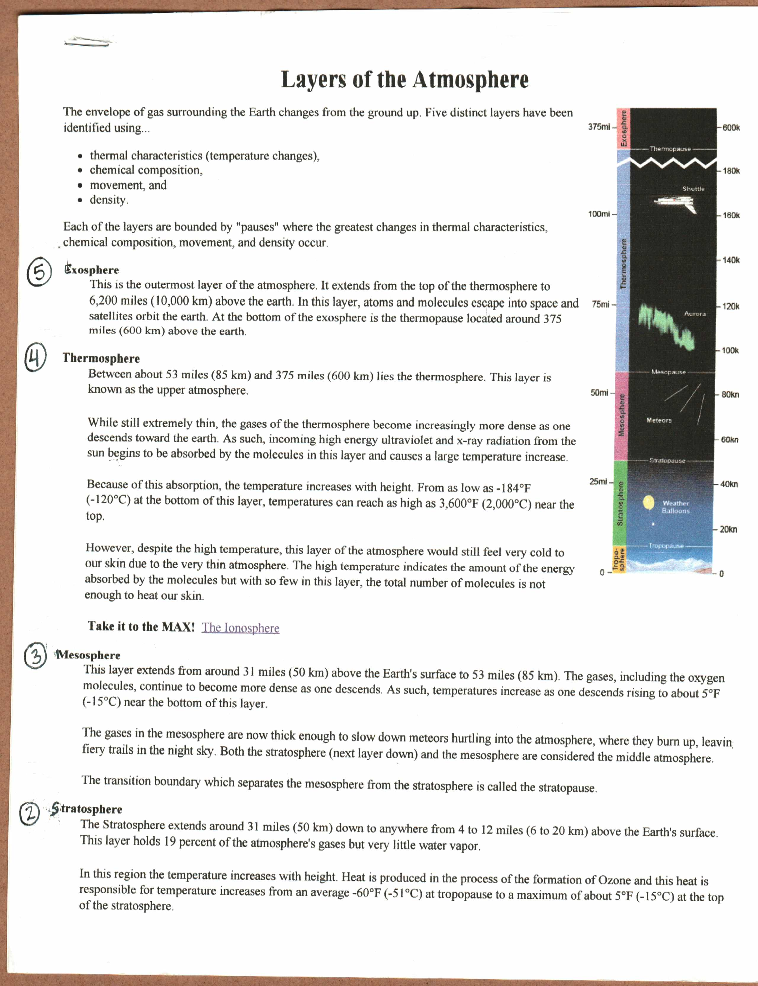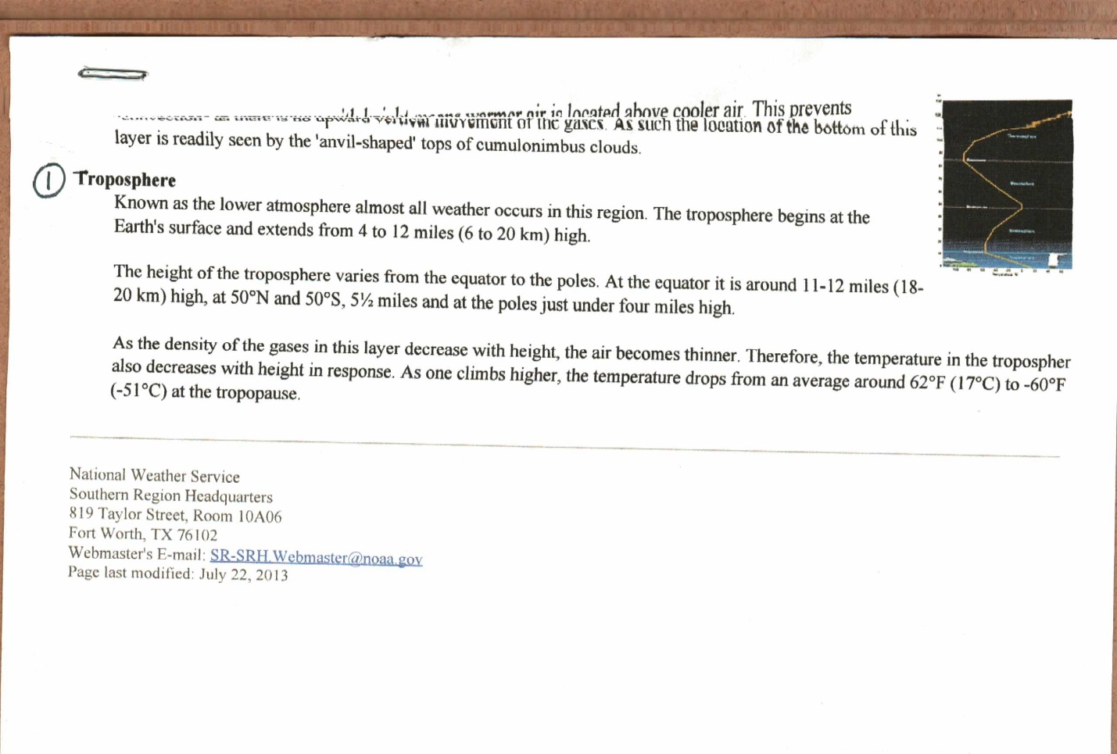

This increase in temperature with the height means warmer air is located above cooler air. This prevents ‘convection’ as there is no upward vertical movement of the gases, As such, the location of the bottom of this layer is readily seen by the anvil-shaped tops of cumulonimbus clouds.