Name:_______________________________Class Period:__________Date:___________

Book I – Chapter 2
Lesson 1 Review

You will use your book, class notes and WebQuest Packet to answer the following questions.

THE QUIZ WILL COVER INFORMATION FROM THESE RESOURCES.

1. Define the term weather.
Weather is the condition of the atmosphere at a
specific time.

2. Fill in the blanks using the following terms.

condensation precipitation evaporation

Water continuously moves through a cycle on Earth. Water that falls to Earth as a liquid or solid is known as precipitation. When liquid water changes to water vapor, this process is known as evaporation. When water vapor is cooled, it changes into liquid water. This process is called condensation.

3. Fill in the blanks to complete the description of the different parts of the water cycle.

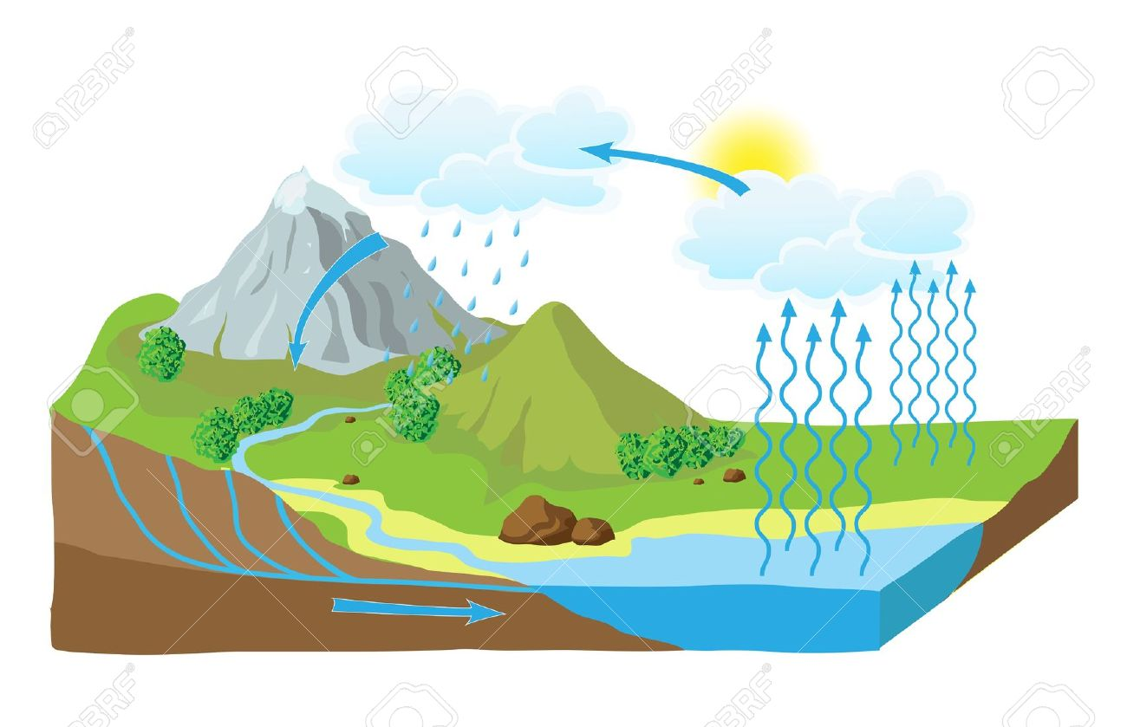

C

D
B
A

The Sun heats surface water, turning it into water vapor. A. evaporation.
When water vapor rises and cools, it forms clouds through the process of B. condensation.
Water falls to the surface as rain, sleet or snow. C. precipitation.
Water returns to oceans to begin the water cycle. D. run-off.

4. How does temperature affect humidity?

Humidity is a measure of the amount of water vapor in the air. The temperature of the air (and the troposphere in general) affects how much water vapor the air can ‘hold’ before the water vapor condenses and turns into a liquid. As the air temperature increases, the air can hold more water vapor. Cooler air temperatures restrict the amount of water vapor that can exist.

HIGH TEMPERATURES = HIGHER AMOUNTS OF WATER VAPOR IN THE AIR
LOW TEMPERATURES = LOW AMOUNTS OF WATER VAPOR IN THE AIR

Draw a simple graph to support your answer.

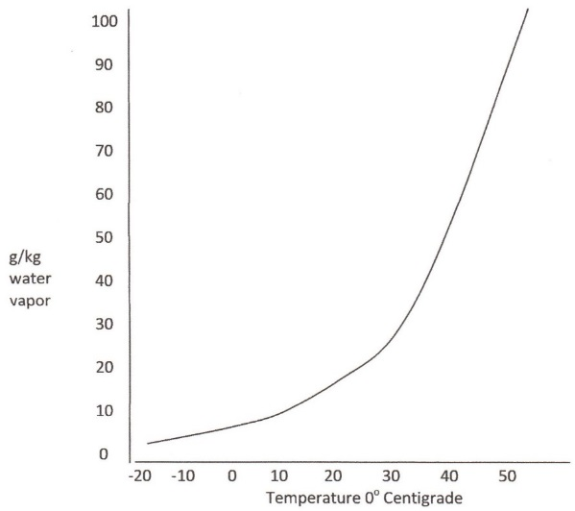

5. Explain the term “dew point” and how it connects to the formation of dew on surfaces in the early morning or at night.
Dew point is the temperature at which water vapor condenses into a liquid. When air masses heat up, they can hold more water vapor. As the air mass cools down, the water vapor is ‘squeezed’ out and condenses on surfaces. This process commonly occurs in the early morning or at night time during the summer; air masses heat up during the day and hold a large amount of water vapor and at night time (or early morning) the air mass is cooler, causing water vapor to condense on surfaces such as grass.

6. How do scientists gather information about water on Earth? (WebQuest)
Orbiting satellites collect most of the data about the Earth’s water supply. In addition, scientific observations and data collection at the surface are other methods for gathering data about the water on Earth.

7. Place the following steps of the water cycle in order. The first and last step have been identified.
STEP IN WATER CYCLE | DESCRIPTION OF PROCESS
3 | Air masses cool, causing water vapor to condense.
5 | Precipitation falls to Earth from clouds once condensed droplets become a certain size.
1 | Energy from the sun causes surface water to evaporate.
6 | Water collects on the surface or infiltrates into the ground.
2 | Warm air masses hold large amounts of water vapor and rise through the troposphere.
7 | Water from precipitation returns to lakes, rivers and oceans to continue the water cycle.
4 | Millions of water droplets condense to form a cloud.

