Progressive Era Muckrakers
Directions: Research each muckraker to complete the table.

Muckraker | Work(s) | Subject(s) | Result
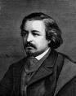
Thomas Nast
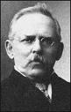
Jacob Riis
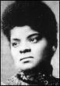
Ida B. Wells
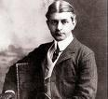
Frank Norris

Ida Tarbell
Lincoln Steffens
Upton Sinclair

Progressive Era Muckrakers
- Whose corruption did the cartoons of Thomas Nast expose?

- What was the name of Jacob Riis’ book?

- What effect did Riis’ book have on society?

- What did Ida B. Wells write about?

- Who wrote The Octopus? What was it about?

- Who did Ida Tarbell write about?

- What effect did Tarbell’s work have on society?

- What was The Jungle about?

- What do you think the Pure Food and Drug Act and the Meat Inspection Act do?

- What issues are reporters presently working to expose and reform?

