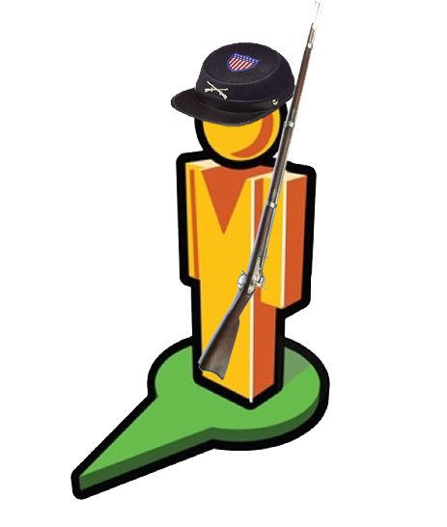 Explore Fort Sumter with

Named for a Revolutionary War Hero, Fort Sumter (1) was built after the War of 1812. It was designed to protect the Harbor in Charleston, South Carolina. 70,000 tons of granite were imported from New England to build up an island (2) at the entrance to this important seaport. The fort (3) was built as a five-sided brick structure with enough room to house 650 men and 135 cannons on three levels (4). At the time of construction it was considered to be one of the strongest forts in world. It is most famous for its first battle in 1861- the start of the American Civil War.

On December 20, 1860, South Carolina seceded from the Union. A few days later, Union Army Major Robert Anderson secretly moved his troops and weapons to Fort Sumter from nearby Fort Moultrie (5). Even though Sumter was not complete, he knew it was a much stronger fort with a better location to defend against a possible Confederate attack. A couple of weeks later, on January 9, 1861 the Union supply ship Star of the West (6) attempted to resupply Fort Sumter with soldiers and supplies. The South Carolina militia fired on the ship in what would become the first shots of the American Civil War. This ship was unarmed and turned away to safety. Fort Sumter was left high and dry – it would run out of supplies in 3 months if ships could not deliver food and men.

The Confederate command successfully prevented Fort Sumter from receiving reinforcements. They continued to build up the smaller forts (called batteries) around Charleston Harbor. All their cannons were aimed at Fort Sumter and the water that surrounded it. President Lincoln knew of Sumter’s grim situation and ordered a fleet of Union ships to resupply the fort. They carried food, cannons, ammunition, and 300 soldiers towards Charleston Harbor. When the Confederate forces were notified that a resupply was headed to Fort Sumter they demanded a surrender of the fort. When Union Major Robert Anderson refused to leave Fort Sumter, Confederate forces fired upon the fort (7) from the shores of Charleston Harbor. This was the first battle of the American Civil War.

Union soldiers waited more than 2 hours before returning fire (8) to the South Carolina militia. Although Fort Sumter was a grand, sturdy structure, a number of factors doomed the Union army that occupied it. It was not fully supplied and had fewer than half its cannons and ammunition ready for battle. Some of the ammunition was useless because the fort didn’t have fuses to light it. The Union had to fire their cannons sparingly (9) in order to conserve their limited ammunition. Cannons on the top level (10) of Sumter had the best view and most direct shot on the enemy, but Major Anderson did not use these high guns because that would have exposed his men to Confederate fire. The South Carolina Militia was well-armed (11) and continuously shelled Sumter (12), resulting in significant damage (13). During the attack, the Union flag was hit and fell to the ground. Lt. Norman J. Hall risked life to raise the flag back up, burning off his eyebrows in the process. At night the Confederate fire slowed down, though they still fired occasionally. The next morning, 34 hours after the first shot was fired, the fort was surrendered (14). No deaths resulted because of this battle; however, 2 soldiers died during a 100-gun salute at the surrender ceremony. Fort Sumter was battered, but would be rebuilt.

The Union soldiers from Sumter were carried north to New York City on the ship “Star of the West,” the original supply ship that received the first shot of the American Civil War. The Union flag that flew over Fort Sumter became a popular patriotic symbol after Major Anderson returned north with it. The flag (15) is still displayed in the fort’s museum today.
Use this website if you can’t click on the links above: https://goo.gl/0GxJEC

1. Review the flags present in link #1 and this excerpt from the National Park Service. Then match each flag to its description.

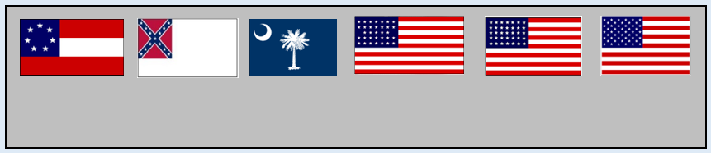
“There are 5 flags present at modern day Sumter. The first, and tallest, is the current US 50 – star flag. Other US flags include the 33 star and the 35 star, which represented the Union at the beginning and end of the Civil War. The first confederate flag or “stars and bars” was flown after Sumter was captured the first time. The second confederate flag contains the more recognizable diagonal star design. Lastly, the state flag of South Carolina is also displayed.”
Second Confederate flag
50 Star US Flag
First Confederate flag
35 Star (End of Civil War)
South Carolina State flag
33 Star (Start of Civil War)

2. Place the following events in order on the timeline.
President Lincoln ordered a resupply of Sumter
South Carolina seceded from the Union
Star of the West was given a warning shot
Anderson refused to surrender Sumter
South Carolina Militia fires upon Sumter
Anderson moved his troops to Fort Sumter from Fort Moultrie

3. Look at the map in link #5. Fort Sumter and Fort Moultrie are labeled on the map. There is one more fort visible. This was the fort that first fired on Sumter. What is the name of that fort?

4. Reread paragraph 2. Describe what is happening in this illustration, which appeared in Harper’s Weekly on January 26, 1861.

5. Review link #8. What clues tell you that this illustration shows the Union’s first shot?

6. Review link #10. The title of this illustration is “Scenes on the Ramparts of Fort Sumter.”

-What patriotic song includes the phrase “O’er the ramparts we watched, were so gallantly streaming?” –

-Based on the illustration, what is a rampart?

7. Look at the illustration in link 11. What evidence supports the idea that the South Carolina Militia was well – armed?

8. The illustration in link 12 shows the Confederate forces firing on Fort Sumter from how many sides?

9. Describe what the Union Soldiers are doing in link 13.

10. What flag is flying over Fort Sumter in link 14? Describe the condition of the fort.

