Name: ___________________________ Date: 4/01/19 Period: 1
US History: WWII the American Home Front
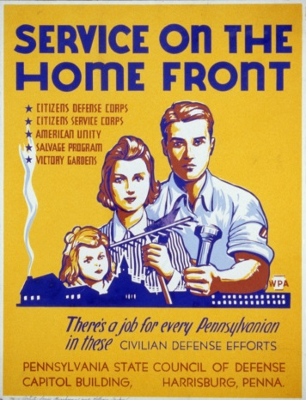
The United States participated in the Second World War from 1941 until 1945 and the conflict had a deep impact on American society. The high demand for soldiers, weapons, and money to fight the war changed the way Americans lived their lives. Just like in the First World War the United States sent soldiers to fight in Europe while civilians stayed home on the Home Front. However during the Second World War, the changes that this dynamic caused were more permanent.
The “Home Front” is a term that describes the physical United States and the events that happened there while the U.S. Army was fighting in Europe and the Pacific.
What were propaganda posters encouraging American citizens to do at home during the war?
__________________________________________________________________________________________________________________________________________________________________

- What did the war require that changed the American way of life in 1941?
____________________________________________________________________________________________________________________________________________________________
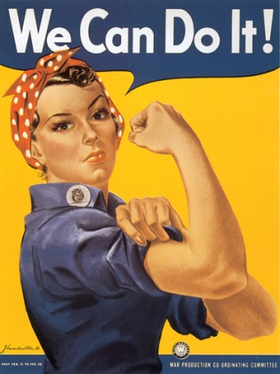
The largest and most obvious change that WWII caused on the Home Front was the return of American women to the workforce in huge numbers. The army had drafted over 2 million American men and sent them to Europe and the Pacific to fight in the war. This left very few men to work in factories so the owners once again hired millions of women to work for them just like they had in WWI. Women were encouraged by the government to support the war effort with propaganda and they answered the call in huge numbers. By 1944, 75% of the American workforce was female and it supported the entire war effort for four years.
The Department of Commerce developed propaganda posters like this one to inspire women to support the war effort without actually fighting. Rosie the Riveter became a mascot for women who worked in shipyards.
What is the message for women that this poster is sending?
___________________________________________________________________________________________________________________________________________________________________________

- How did the American entry into WWII affect the women of the United States?
____________________________________________________________________________________________________________________________________________________________
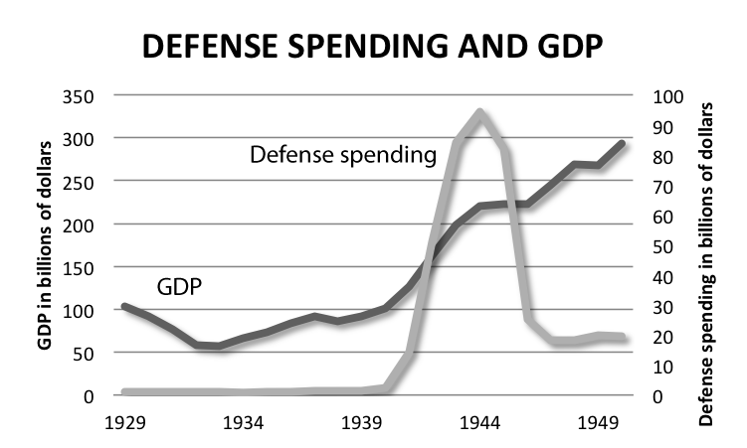
Waging a global war is one of the most expensive things that a government can do. It cost billions of dollars to create, train, feed, and supply an army big enough to defeat the Nazis and the Japanese. The US was also geographically isolated from Europe and Japan so a large navy needed to be built to transport the troops and their supplies across the world’s oceans to fight. In order to pay for these expenses, President Roosevelt approved a massive spending bill that would allow the government to pay for things on credit. Roosevelt promised the companies that sold material to the army that the government would pay them back later. This policy allowed the government to raise a huge army and navy in a short period of time but it caused the whole country to go into serious debt.
When the Second World War broke out the United States shifted from making civilian products to war material (which was much more expensive). As a result, the national debt tripled in just four years.
According to this chart, what year had the highest amount of defense spending?
________________________________________________________________________________________

- What did the government need to fight the war and how did FDR plan to pay for it?
____________________________________________________________________________________________________________________________________________________________
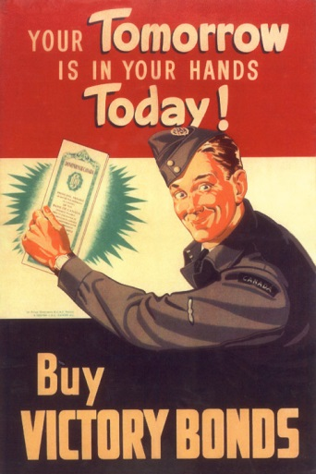
Roosevelt knew that he had to get the debt down in order to avoid another depression so in order to pay the military contractors the money he owed them, he reestablished the War Bond Program. Just like Woodrow Wilson in 1917, Roosevelt sold war bonds to the American people in order to raise cash immediately. The government used patriotic advertisements to convince American citizens to buy them and the government was able to raise billions of dollars quickly.
War Bonds are small loans that everyday Americans made to the government every time they bought one. When millions of Americans each bought war bonds in small amounts, it allowed the government to raise a large amount of money quickly.
Why do you think the government called them “Victory Bonds” instead of “Bloody, explosion machine gun battle bonds”?
___________________________________________________________________________________________________________________________________________________________________________________________________

- How did the government pay back all the money that they owed to munitions factories?
__________________________________________________________________________________________________________________________________________________________________________________________________________________________________________
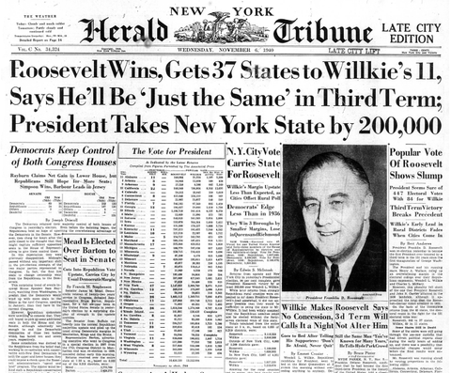
While FDR was working to fix the economy and prepare the nation for war with the Nazis, his second term as president ended in 1940. He truly believed that if the United States was going to continue to succeed, it should not change leaders in the middle of a crisis. That is why, in July of 1939, Franklin Roosevelt ran for a third term as President of the United States. It was the first time in American history that a president broke the precedent set by George Washington way back in 1790. Roosevelt was elected by a landslide and became the first and only president to serve more than two terms.
Roosevelt was the first and only President to ever get elected more than twice. He was elected an unprecedented fourth time in 1944 but died of a brain aneurysm in April of 1945. After the war, Congress passed an amendment to the Constitution that prevented anyone from getting elected more than twice by law.
What did Roosevelt promise to be in his third term in order to keep everyone calm?
___________________________________________________________________________________________________________________________________________________________________________

- What did Roosevelt do in 1940 that was unprecedented?
____________________________________________________________________________________________________________________________________________________________
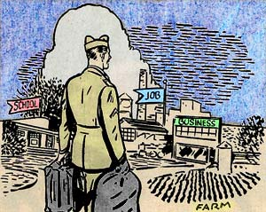
Roosevelt died in April of 1945 and was replaced by his vice president, Harry Truman. Truman successfully led the country through to the end of the war and oversaw the withdrawal of American troops from Europe and the Pacific. Truman knew that these soldiers needed jobs and places to live so he organized a government program to help them get it. In 1946 Truman reorganized the G.I. Bill which paid for college education for every soldier that had served in combat for the United States during the war. Hundreds of thousands of troops used the G.I. Bill to get their college degrees and by the 1950s the United States had the largest college educated population in the world (beating England in 1952).
Unlike WWI veterans who had to rely on their combat pay to survive when they got home, WWII veterans had access to loans for homes, school, and businesses which jumpstarted the civilian economy after the war.
Would you serve in the army if it meant getting free college tuition when you were finished? Why or why not?
_______________________________________________________________________________________________________________________________________________________________________________________

- What did the government do to provide for the veterans returning from WWII?
____________________________________________________________________________________________________________________________________________________________

