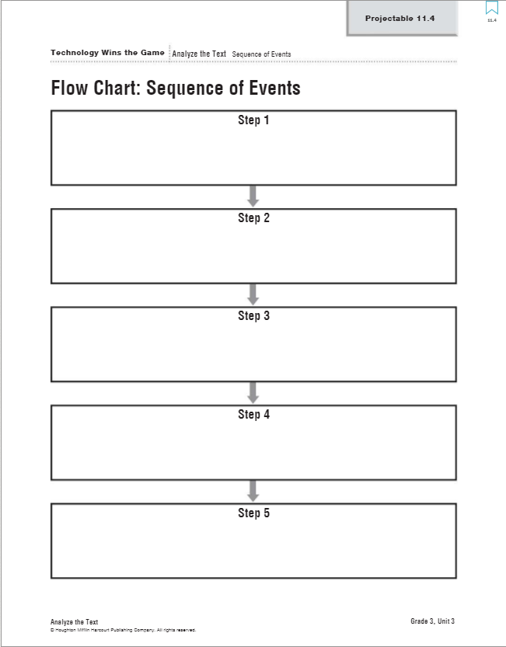
Name:

Copy and Paste the sequence order clues into the small
boxes on the previous page.
First,
Then,
Next,
Finally,

Cut and Paste the following sentences in the correct
Sequence of events in the bigger boxes.

sports engineers have athletes test the new product.
they create a model of the solution.
sports engineers identify a problem in a sport.
sports engineers come up with ideas for solutions.
they test the model in a laboratory.

