Microsoft Word Lesson
4th Grade
Name:
Make the following changes to your name:
- Change the font to chiller.
- Change the size to 20.
- Change the color to orange.
Use ctrl + x (cut) and ctrl + v (paste) to cut and paste the list of words into alphabetical order.
Halloween
Witch
Pumpkin
Scary
October
Skeleton
Scarecrow
Vampire
Ghost
Use ctrl + c (copy) and ctrl + v (paste) to copy and paste the list of words in alphabetical order again below. Change the font of all words below to chiller.

Use ctrl + c (copy) and ctrl + v (paste) to copy and paste the correct word above the picture.

 | 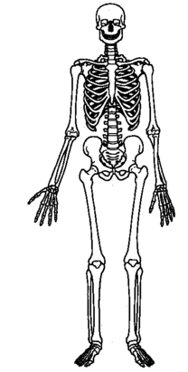 | 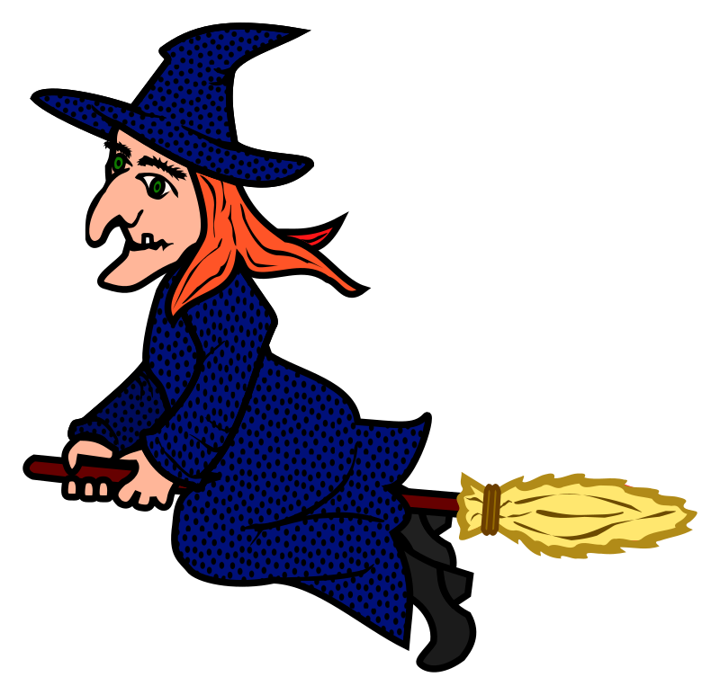
 | 