Type a caption for your photo  Storm name  Type storm information here. | Name  This brochure was created after researching various types of storms. Hopefully you learned more about each one. | Storms  - Learn more about haboobs, hurricanes, tornados, and tsunamis.
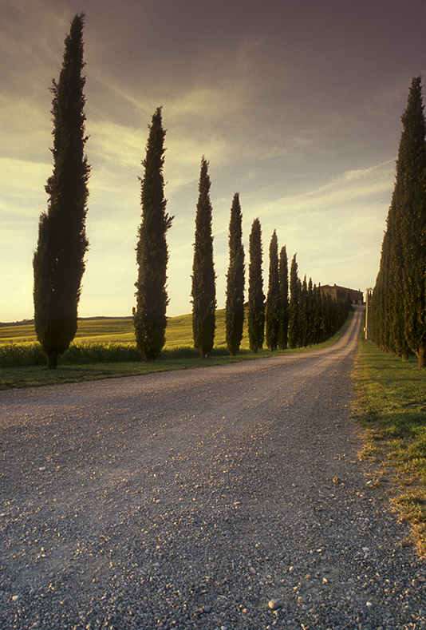  Type a caption for your photo  Storm name  Type storm information here. | Storm name  Type storm information here.  Type a caption for your photo | 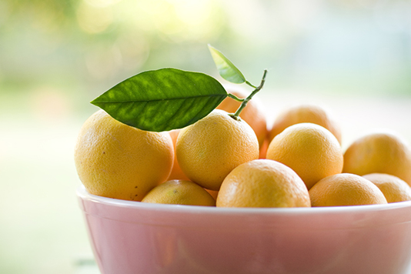  Type a caption for your photo  Storm name  Type storm information here.

