Name: _______________________________________ Date: _______________ Period: _____ Rev. 5/18
Summative Reassessment Form
Please fill out this form to reassess your summative assessment. You are expected to follow the steps outlined here for your opportunity to reassess. The NEWEST score will be recorded in the gradebook.
Steps to take for the opportunity for to reassess:
- Complete this form with parent signature. All areas of this form need to be completed with specific details.
- Return all missing and incomplete assignments attached to this unit of study.
- WITHIN THE DETERMINED NUMBER OF SCHOOL DAYS OF THE ASSESSMENT HANDED BACK--- Sign up for a reassessment date and time with the teacher. Be sure to bring all required materials (late work & original assessment).
Assessment Title: __________________________________________ Class: _______________ Score: _______
What steps did you take to prepare for the original assessment (studying)? ___________________________
_______________________________________________________________________________________
Why do you believe you earned the score you did? ___________________________________________
_____________________________________________________________________________________
Complete this calendar of what steps you will be taking to study & prepare for your corrections/redo:
Assessment is returned  Mandatory review day  Date: _________ | Mandatory review day  Date: ___________ | Mandatory review day  Date:____________ | Optional review day  Date: ___________ | Optional review day  Date: ___________
Steps I will take today to prepare: | Steps I will take today to prepare: | Steps I will take today to prepare: | Steps I will take today to prepare: | Steps I will take today to prepare:
Here are some ideas for study tools for daily preparation:
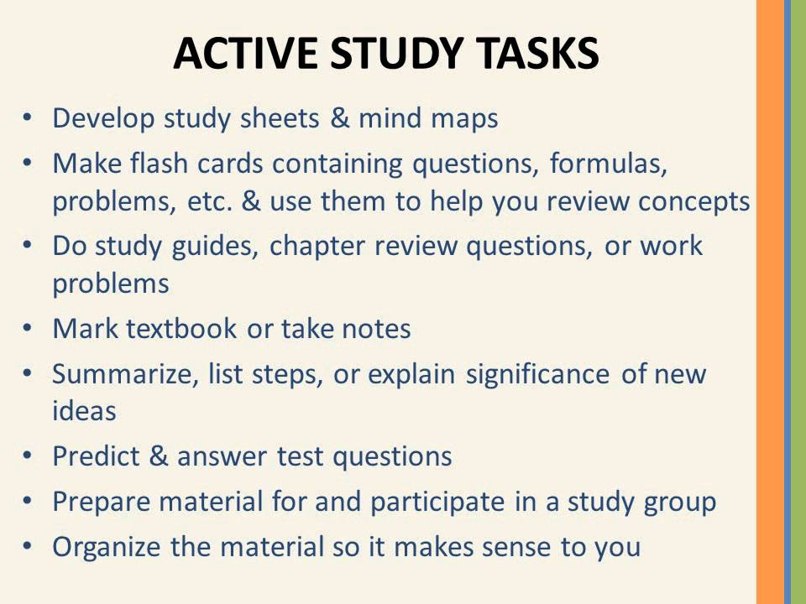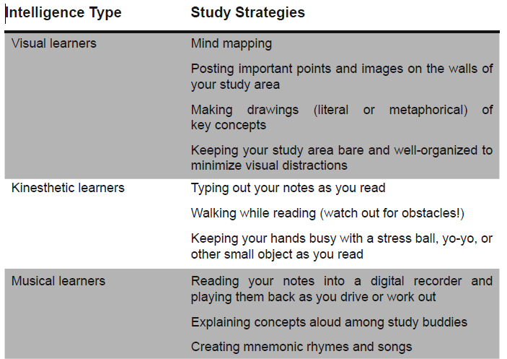
Original assessment must be handed in with this form.
Student signature: _______________________ Parent signature: _______________________________ Date: _______

