Hurricane Katrina
  - By: Mrs. Fish
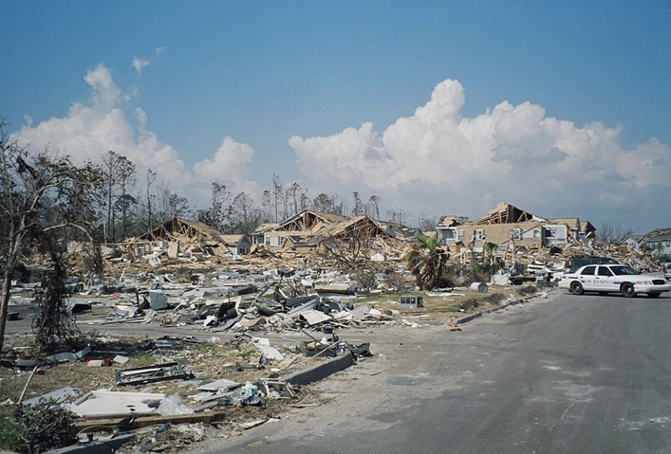
- Date(s): August 29, 2005
- Areas Affected: Gulf Coast of the United States- Louisiana (New Orleans), Mississippi, Alabama and Mexico
- Category: 3
- Wind Speeds: 100-140 miles per hour
- Fatalities: 2,000 people
- Damage Costs: $100 billion in damage
- Aftermath: levee breaches, massive flooding, people were displaced from their homes/left homeless, missing people and pets.

Hurricane Katrina Facts:
- Hurricane Katrina stretch some 400 miles across.
- Hundreds of thousands of people in Louisiana, Mississippi, and Alabama were displaced from their homes.
- Hurricane Katrina formed over the Bahamas on August 23, 2005.
- Hurricanes have flooded New Orleans six times (1915, 1940, 1947, 1965, 1969, and 2005).
- The day before Katrina hit, New Orleans was issued the city’s first mandatory evacuation order.

What is a Hurricane?:
A hurricane is …. A hurricane is formed when …

Hurricane Safety Tips:
- Have a plan for your family, pets, and house!

Saffir-Simpson Hurricane Scale:
Category | Winds | Damage
1
2
3
4
5

Sources:
- https://www.history.com/topics/natural-disasters-and-environment/hurricane-katrina
- http://www.weatherwizkids.com/weather-hurricane.htm

