

**This week in:**

**Mrs. Hodys’ Class**



Scientist of the Month

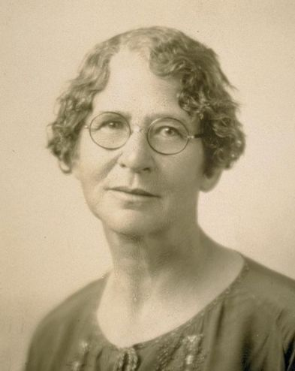

Ynes Mexia

1870-1938

**Nationality:** Mexican-American

**Known For:** Studying plants. She was a botanist.

**Studied:** Botany – study of plant life and how plants interact/evolve.

See more about Ynes Mexia on our Scientist Around the World Wall.

We are learning:

**Math:**

Students have a summative Monday over 1.4-1.7. Students will begin relating multiplication to division by drawing arrays for L1.8. Students will then explore the concept of mathematical expressions and how to evaluate those expressions using PEMDAS.

**Science:**

Students are learning about matter and energy in plants. This unit allows students to explore what plants need to grow in an experiment with seeds, water, and air. Students will explore the different parts of a plant, photosynthesis, chlorophyll, chloroplasts, and how plants help the environment.

Important Reminders

DARE has started; every Tuesday students will have 40 mins of DARE.

Please make sure your student has their bus ID’s on in the morning when they get picked up for their bus. If your child has lost his/her ID, please let me know so a new one can be issued.

#ONEWALKER

Week of Sept. 24th – Sept. 28th

Jhodys@Summithill.org

[This Photo](http://8bchangemaker2010.wikispaces.com/Martin+Luther+King) by Unknown Author is licensed under [CC BY-SA](https://creativecommons.org/licenses/by-sa/3.0/)