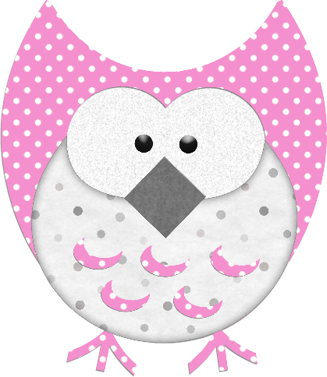

**This week in:**

**Mrs. Hodys’ Class**

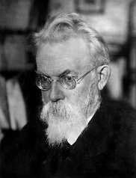[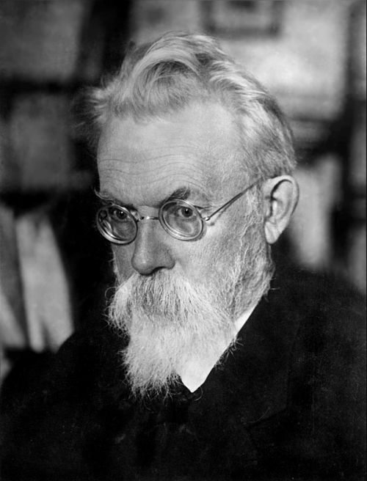](https://en.wikipedia.org/wiki/File:1934-V_I_Vernadsky.jpg)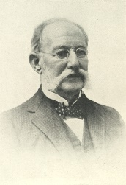****

**Math:**

Multiplying Decimals. How can you multiply decimals with whole numbers? How can you use patterns to solve decimal multiplication? How can you use expanded form and place value to multiply decimals? All of these questions are questions the students will be able to answer before Winter break. Students are exploring Chapter 4 and will have a summative on Wednesday December 19th. This week students are modeling decimal multiplication with whole numbers and with decimals. Continue to practice basic facts.

**Science:**

Students will be practicing their vocabulary through quizlet for Earth’s Systems and Interactions. Students will apply the information from each sphere: atmosphere, geosphere, hydrosphere, and biosphere to create a poster. The majority of our science materials will be available in O365, however, students will still be taking notes and color coding in their science notebooks.

**\*\*Please note any time there is a summative, materials should still be coming home to study. (Both math and science)**

Important Reminders

* 12/10 – NWEA Reading Test
* 12/18 – Holiday Concert Assembly
* 12/19 – Math Summative 4.1-4.3, 4.6, and 4.7
* 12/20 – DARE Celebration
* 12/21 Winter Assembly

Winter already!?! Please dress appropriately for the weather.

#ONEWALKER

Scientist of the Month

Vladimir Vernadsky

1863 - 1945

**Nationality:**  Russian-Ukranian

**Known For:** Minerologist and Geochemist.

**Studied:** Thermal and magnetic properties of crystals. Discovered oxygen, nitrogen, and carbon dioxide developed from natural processes.

See more about Vladimir Vernadsky on our Scientist Around the World Wall.

Week of Dec. 10th – Dec. 14th

Jhodys@Summithill.org

[This Photo](http://8bchangemaker2010.wikispaces.com/Martin+Luther+King) by Unknown Author is licensed under [CC BY-SA](https://creativecommons.org/licenses/by-sa/3.0/)